🤿
ScubaDiverLink
Diver User Guide
scubadiverlink.com
Everything you need to book dives, log dives, and stay connected with the diving community.
Version 1.0 · May 2026 · scubadiverlink.com/login.html

Table of Contents
Table of Contents 2
1. Getting Started 4
1.1 Creating Your Account 4
1.2 Multi-Factor Authentication (MFA) 4
1.3 Verifying Your Email 5
2. Your Dashboard 5
2.1 Overview Page 6
3. My Profile 6
3.1 Personal Info 6
3.2 Profile Photo 7
3.3 Saved Businesses & Trips 7
4. Diving Profile 8
4.1 Experience 8
4.2 Certifications 8
4.3 Dive Types 9
4.4 My Equipment 9
5. Dive Log 10
5.1 Logging a Dive Manually 10
5.2 Importing from a Dive Computer 12
5.3 Stats 13
6. Searching & Booking Trips 13
6.1 Finding Trips 13
6.2 Viewing an Operator or Shop Profile 14
6.3 Booking a Trip 15
6.5 Signing the Waiver 16
6.4 The Seat Map 17
6.6 Paying the Balance 18
7. My Trips 18
7.1 My Bookings 19
7.2 QR Boarding Pass 19
7.3 Sharing Your Trip 20
7.4 Browse Trips 21
7.5 Saved Trips 21
7.6 Vacation Schedule and Location Check-in 21
8. Settings 24
8.1 Emergency Contact 24
8.2 DAN Membership 24
8.3 Notifications 25
8.4 Subscription 25
8.5 Security (MFA & Password) 26
8.6 Platform Updates 27
9. Dive Buddies 27
9.1 Finding Divers 28
9.2 Sending a Buddy Request 29
9.3 Messaging 29
10. Tips & Troubleshooting 30
10.1 Common Issues 30
10.2 Getting Help 30
Appendix — Quick Reference Links 31

1. Getting Started
Create your free ScubaDiverLink account in under two minutes. All you need is an email address. A 14-day free trial is included automatically — no credit card required to sign up.

1.1 Creating Your Account
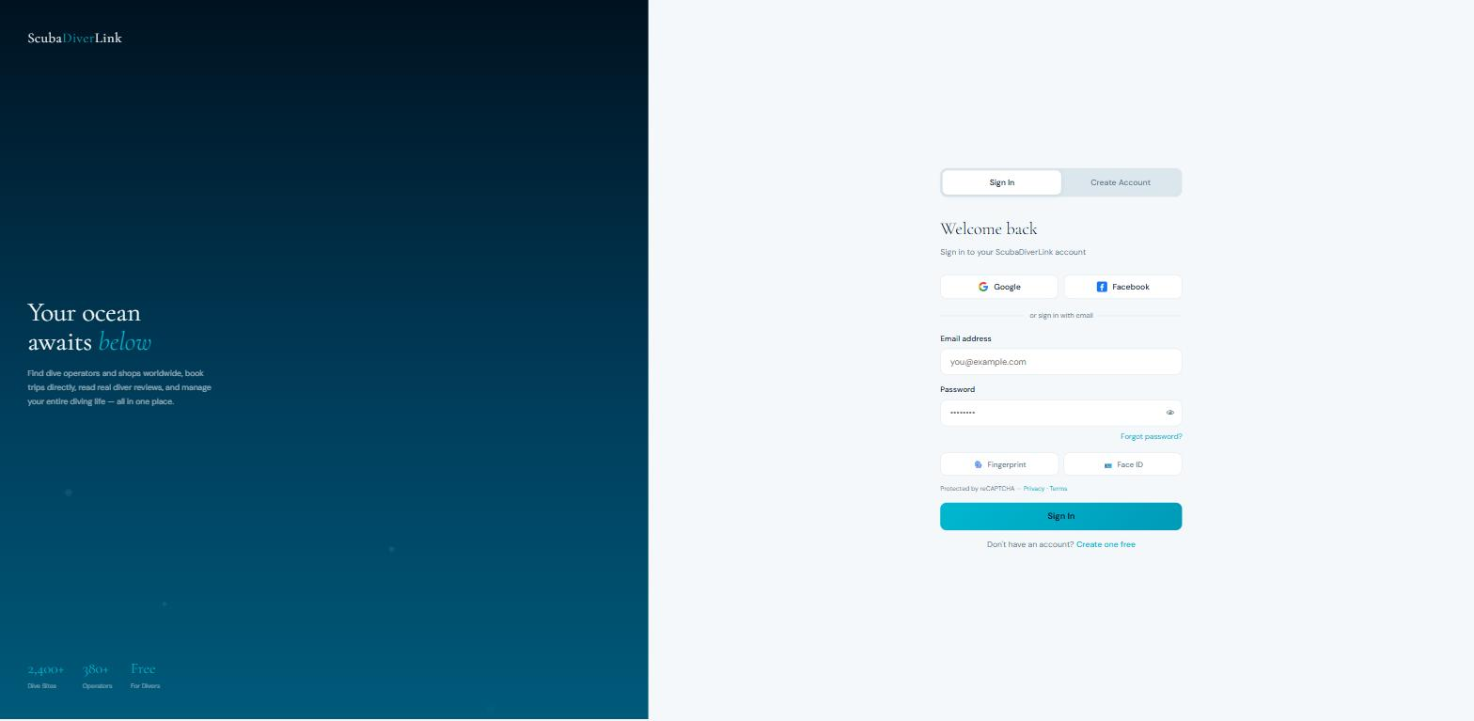

To create an account:
- Go to scubadiverlink.com and click Sign Up.
- Enter your name, email address, and a strong password.
- Click Create Account — you will receive a verification email within a few minutes.
- Click the link in the email to verify your address. You must verify before logging in.

Tip: Check your spam folder if the verification email doesn't arrive within 5 minutes.
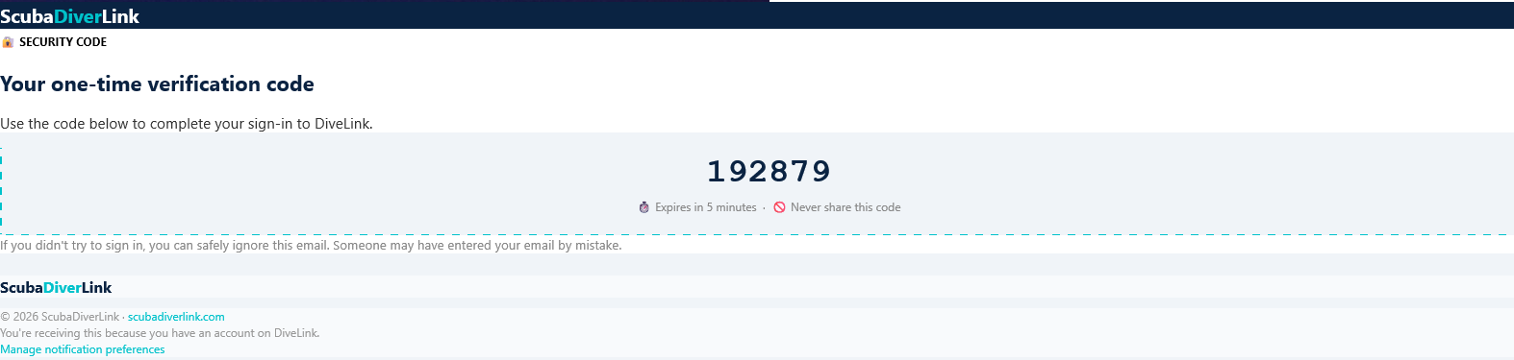

1.2 Multi-Factor Authentication (MFA)
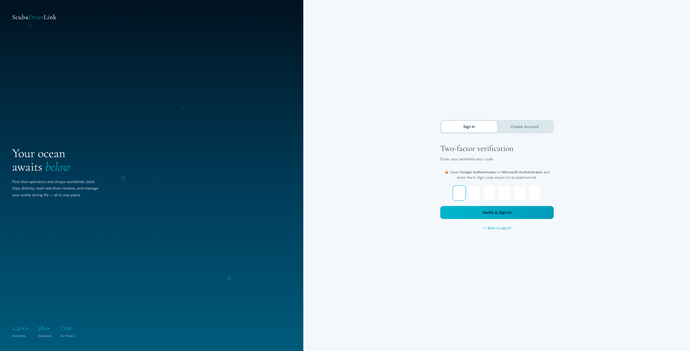
ScubaDiverLink uses mandatory MFA on every login. When you sign in you will be asked for a 6-digit code. Choose your preferred method in Settings → Security:

Email OTP | A code is emailed to your address. Best if you don't have your phone handy.
SMS | A code is texted to your mobile number. Fast and convenient.
WhatsApp | A code is sent via WhatsApp. Requires WhatsApp installed on your phone.
Authenticator App | Generate codes with Google Authenticator, Authy, or any TOTP app. Most secure option — works offline.

1.3 Verifying Your Email
After registration, ScubaDiverLink sends you a verification email from noreply@scubadiverlink.com. Click the Verify Email button inside.
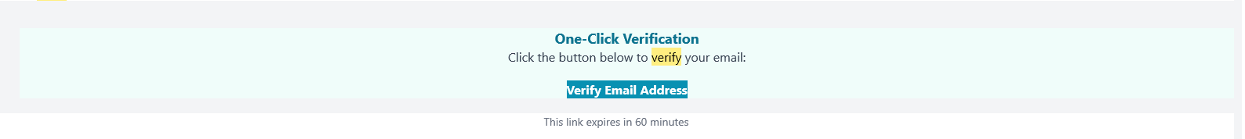
If the link has expired, log in and go to Settings → Security → Resend Verification.

2. Your Dashboard
The Dashboard (Overview) gives you a quick snapshot of your activity and quick links to key areas.

2.1 Overview Page
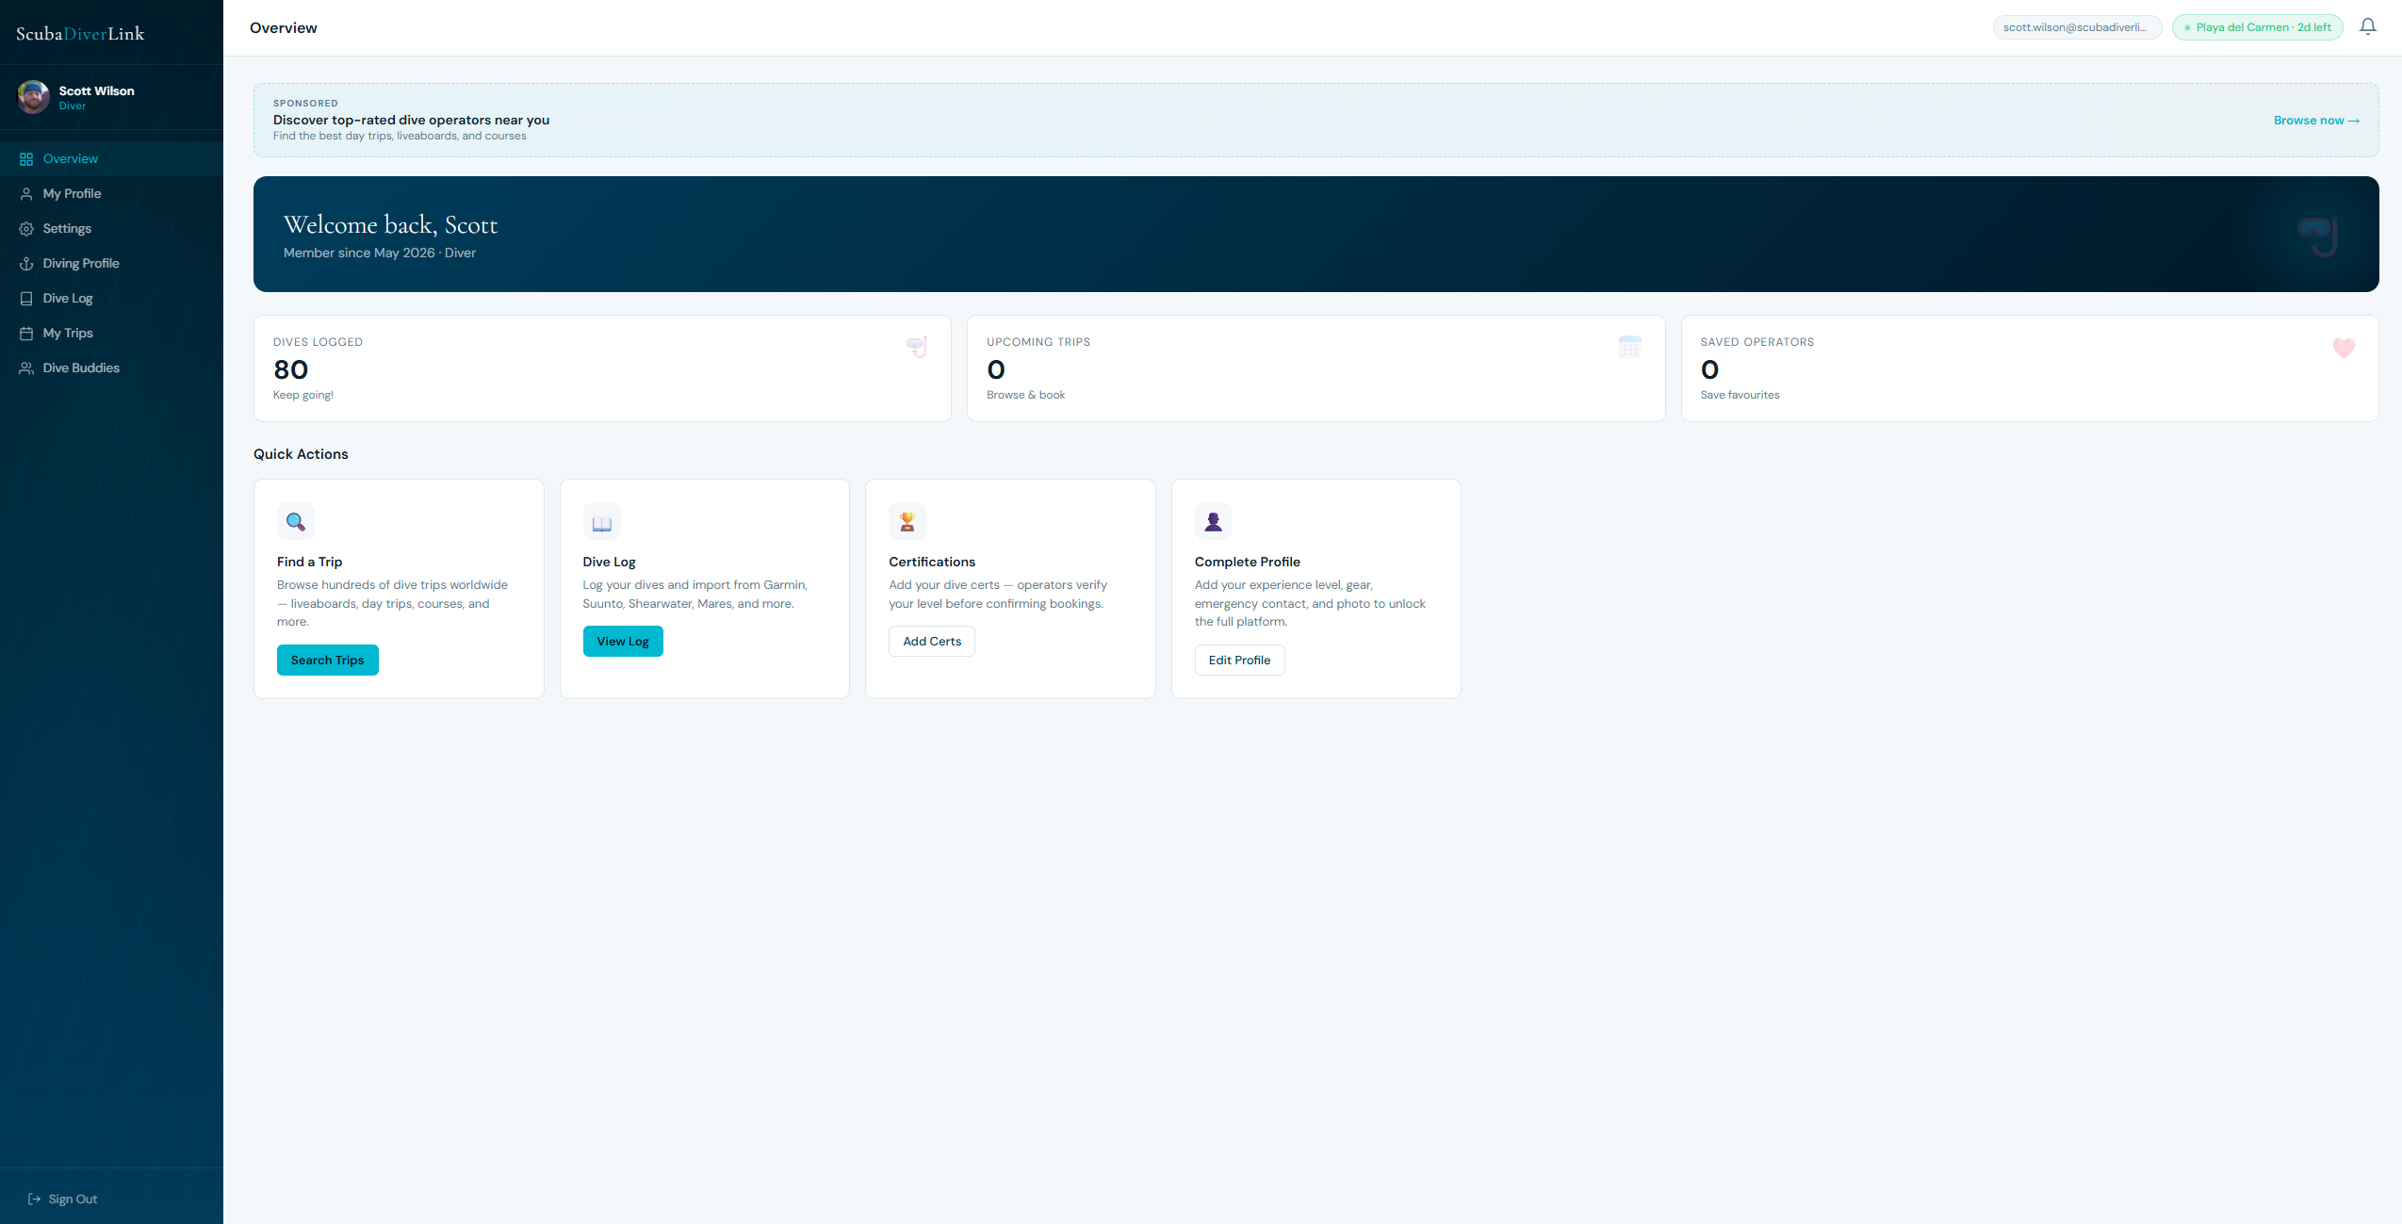
The Overview page shows your personal stats at a glance:
- Upcoming trips — bookings in confirmed or pending status.
- Dives logged — total entries in your dive log.
- Profile completion — percentage of your diving profile filled in.
- Quick-access buttons to Search Trips, My Dive Log, and My Profile.

3. My Profile
Your profile stores your personal information, profile photo, and the list of operators and trips you have saved for later.

3.1 Personal Info
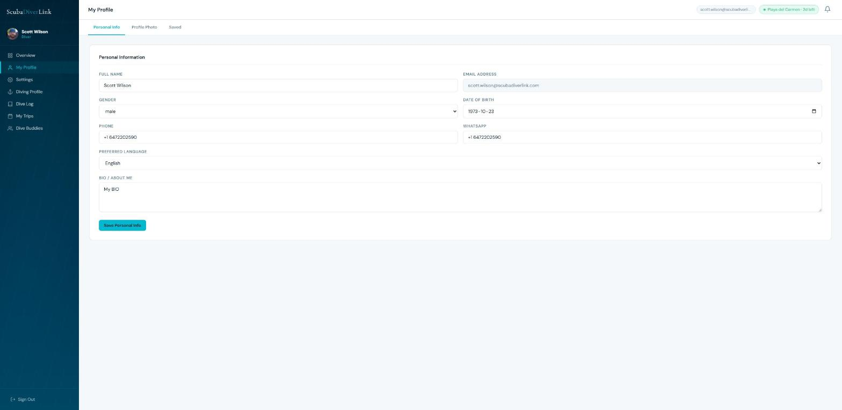
Edit your display name, phone number, country, and bio. Click Save at the bottom of the tab to apply changes.

3.2 Profile Photo
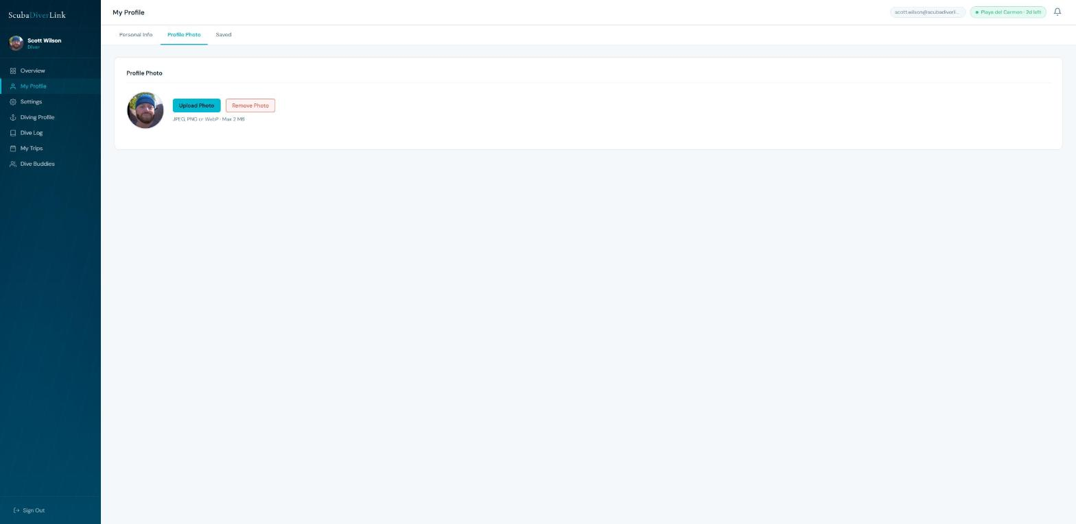

Upload a profile photo (JPEG or PNG, max 5 MB). Your photo appears on your public diver profile and next to your name in bookings and reviews. Drag and drop your image or click Browse to select.

3.3 Saved Businesses & Trips
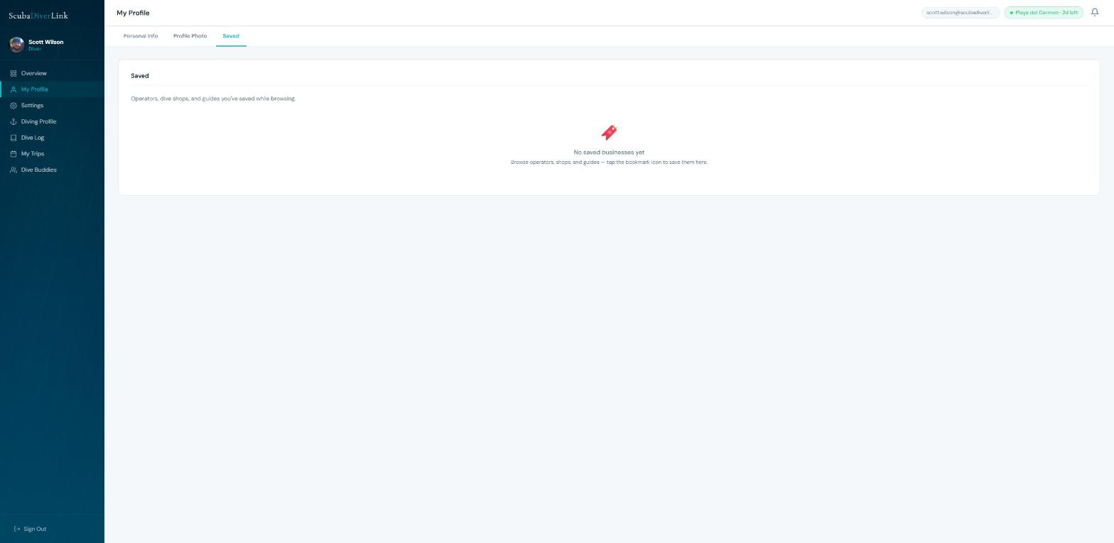
Any operator, shop, or trip you heart-save from a profile or search page appears here. Click a card to return to that listing. Click the filled heart icon to remove it from your saved list.

4. Diving Profile
Your Diving Profile is visible to operators when you book a trip. A complete profile builds trust and may allow you to skip paperwork at check-in.

4.1 Experience
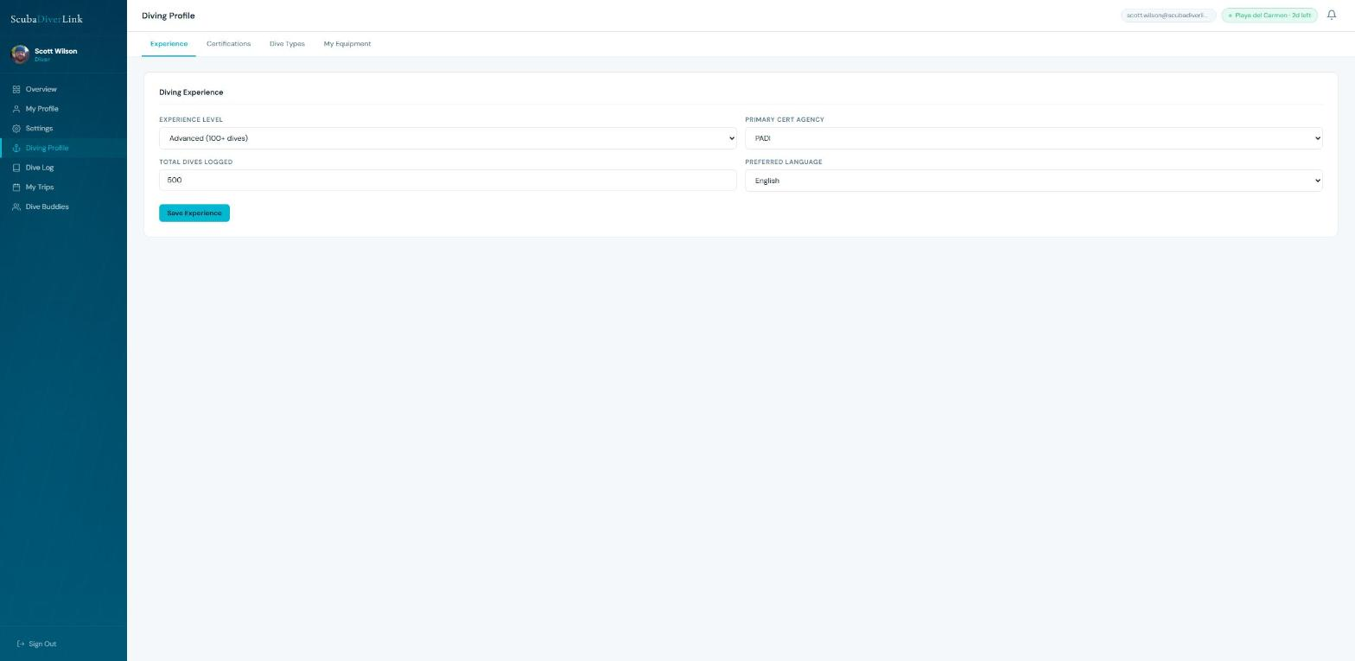
Enter your total logged dives, years of experience, maximum depth, and any specialties. This information is shared with operators when you make a booking.

4.2 Certifications
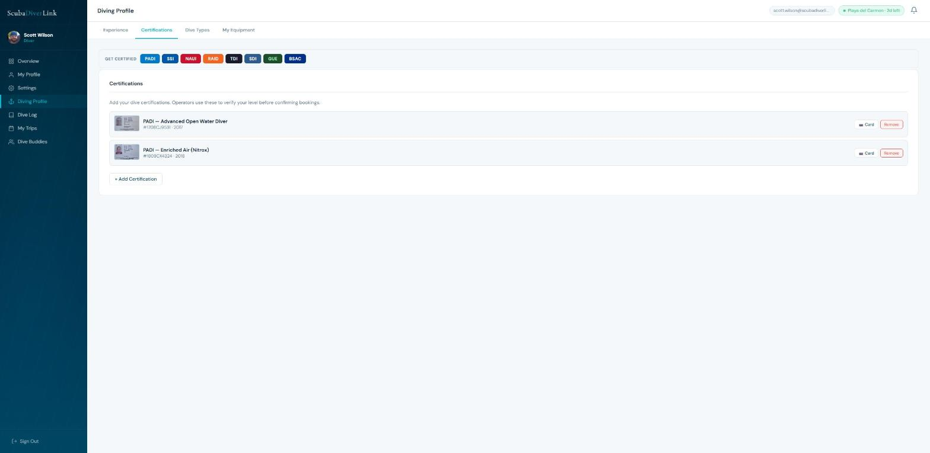
Add all of your diving certifications:
- Click Add Certification and select the agency (PADI, SSI, NAUI, CMAS, etc.) and level.
- Enter your certification number and issue date.
- Optionally upload a photo of your certification card (JPEG/PNG, max 2 MB) — this is stored securely and shared only with operators you book with.

Certifications marked as verified show a green badge on your profile. Operators may use this to pre-approve your booking.

4.3 Dive Types
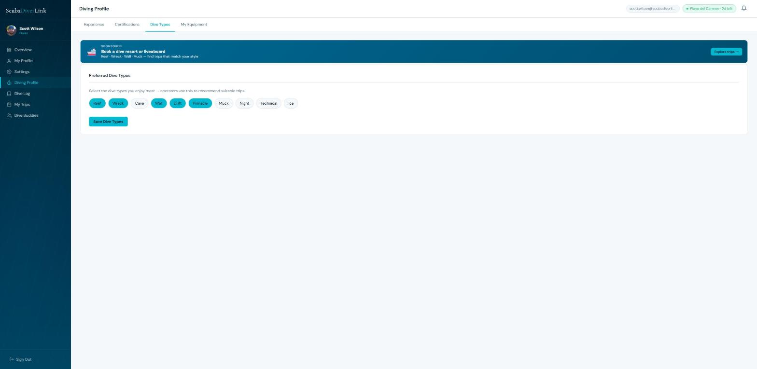
Select the dive types you enjoy or are qualified for. These chips are used to filter your matched trips in the Vacation Schedule feature and help operators understand your interests.

4.4 My Equipment
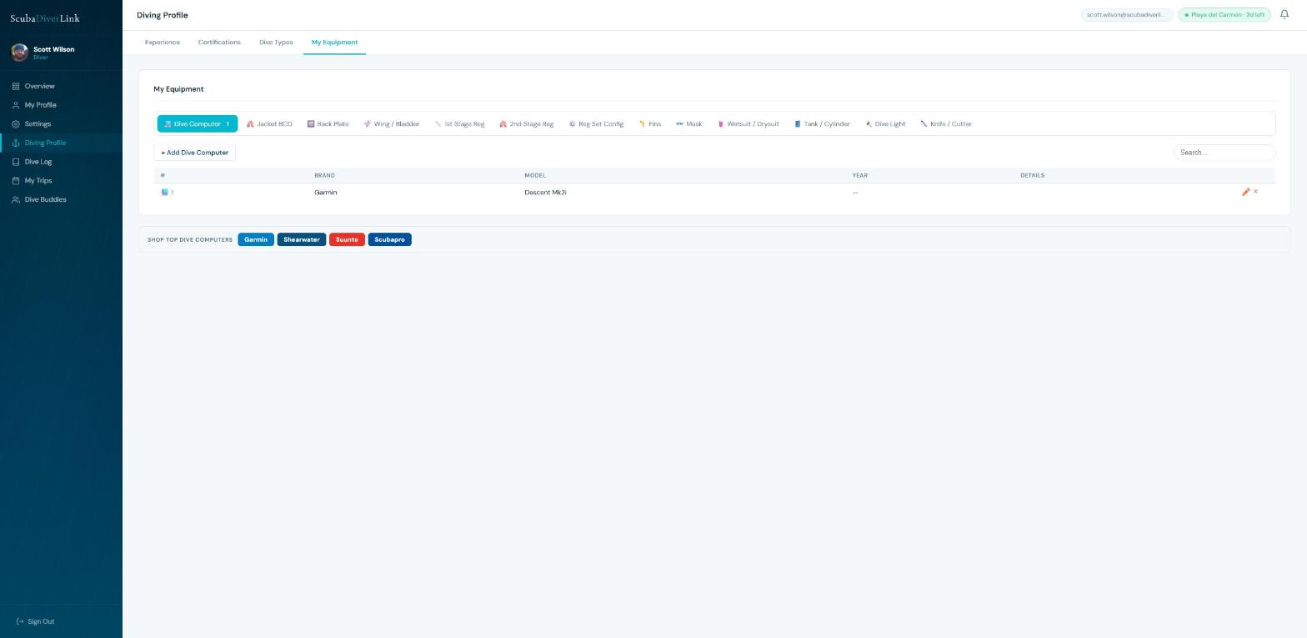
Log your personal gear inventory — dive computers, BCDs, back plates, regulators, wetsuits, fins, and more. For each item, record the brand, model, and serial number. This helps with insurance claims and equipment hire decisions.

5. Dive Log
Your digital logbook. Record every dive, import from popular dive computers, and track your statistics over time.

5.1 Logging a Dive Manually

Click + New Log Entry and fill in the form:
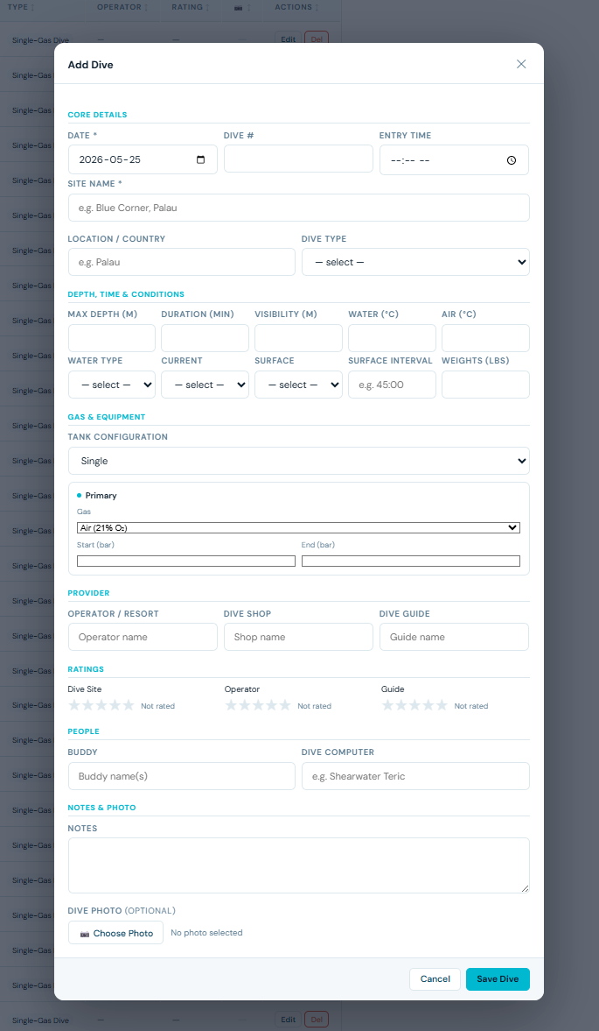

Date & Time | Date and entry time of the dive.
Site | Name of the dive site (required).
Location | City or country.
Max Depth | Deepest point of the dive in metres.
Duration | Bottom time in minutes.
Dive Type | Reef, wreck, cave, freediving, technical, snorkel, etc.
Gas Configuration | Single, doubles, sidemount, sidemount + stage/deco, etc.
Tank Details | Cylinder size, starting & ending pressure, gas mix (air, nitrox, trimix).
Buddy | Name of your dive buddy.
Visibility | Underwater visibility in metres.
Water Temp | Surface and bottom temperature.
Notes & Rating | Free-text notes and a 1–5 star rating.
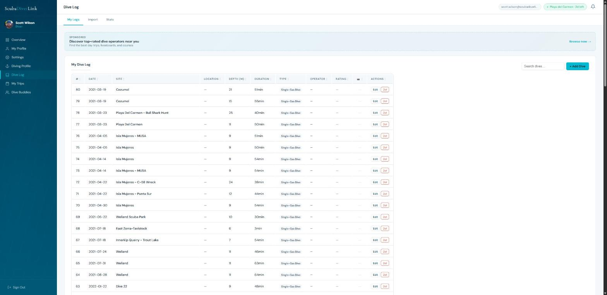

5.2 Importing from a Dive Computer
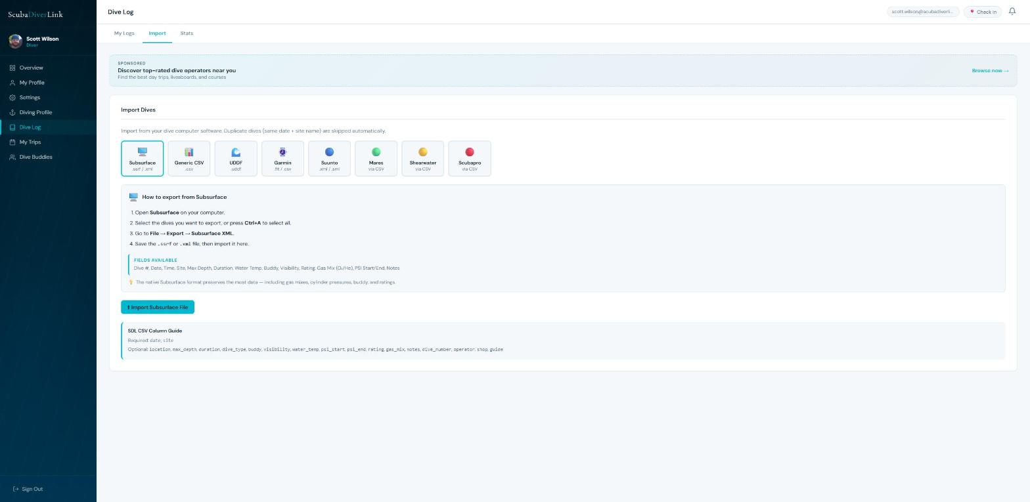
ScubaDiverLink supports importing dives from the following formats:
- Garmin FIT / CSV — export from Garmin Dive or Garmin Connect.
- Suunto SML / XML — export from Suunto DM5 via File → Export.
- Shearwater XML — export from Shearwater Desktop.
- Generic CSV — use the ScubaDiverLink CSV template (date, site, location, max_depth, duration, dive_type, buddy, visibility, water_temp, psi_start, psi_end, rating, gas_mix, notes, dive_number).
- UDDF — depths in metres, temperature in Kelvin (auto-converted), duration in seconds.

After uploading, a preview table shows your dives before import. Review and deselect any duplicates, then click Import Selected.

5.3 Stats
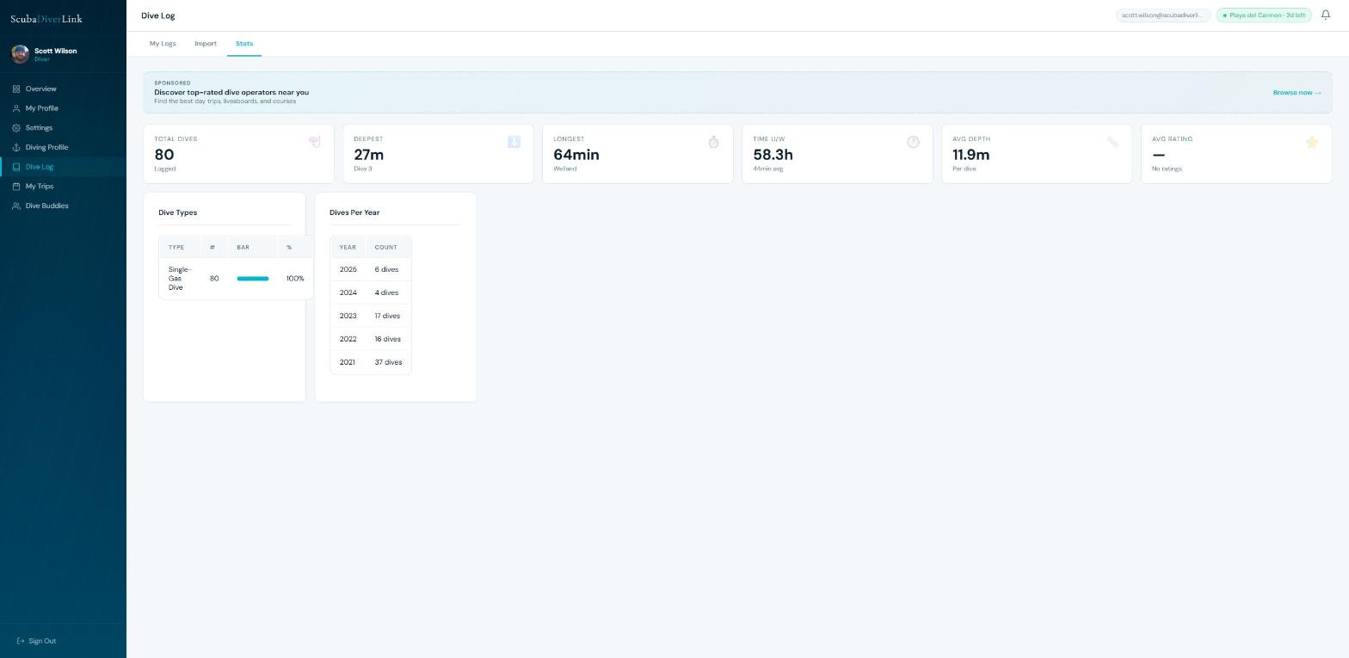
The Stats tab automatically calculates your lifetime dive statistics from your log entries: total dives, deepest dive, total bottom time, average depth, average visibility, and favourite dive sites.

6. Searching & Booking Trips
Browse thousands of dive trips worldwide. Filter by location, type, date, depth, and certification. Book directly through the platform with a secure deposit.

6.1 Finding Trips
Go to Search from the main navigation. Use the filters panel to narrow results:
- Location — type a city, country, or region.
- Trip Type — reef, wreck, cave, liveaboard, day trip, course, snorkel, freediving, technical, charter.
- Date range — search for trips departing within a specific window.
- Certification level — filter to trips that match your certifications.
- Price range — set a minimum and maximum price per seat.
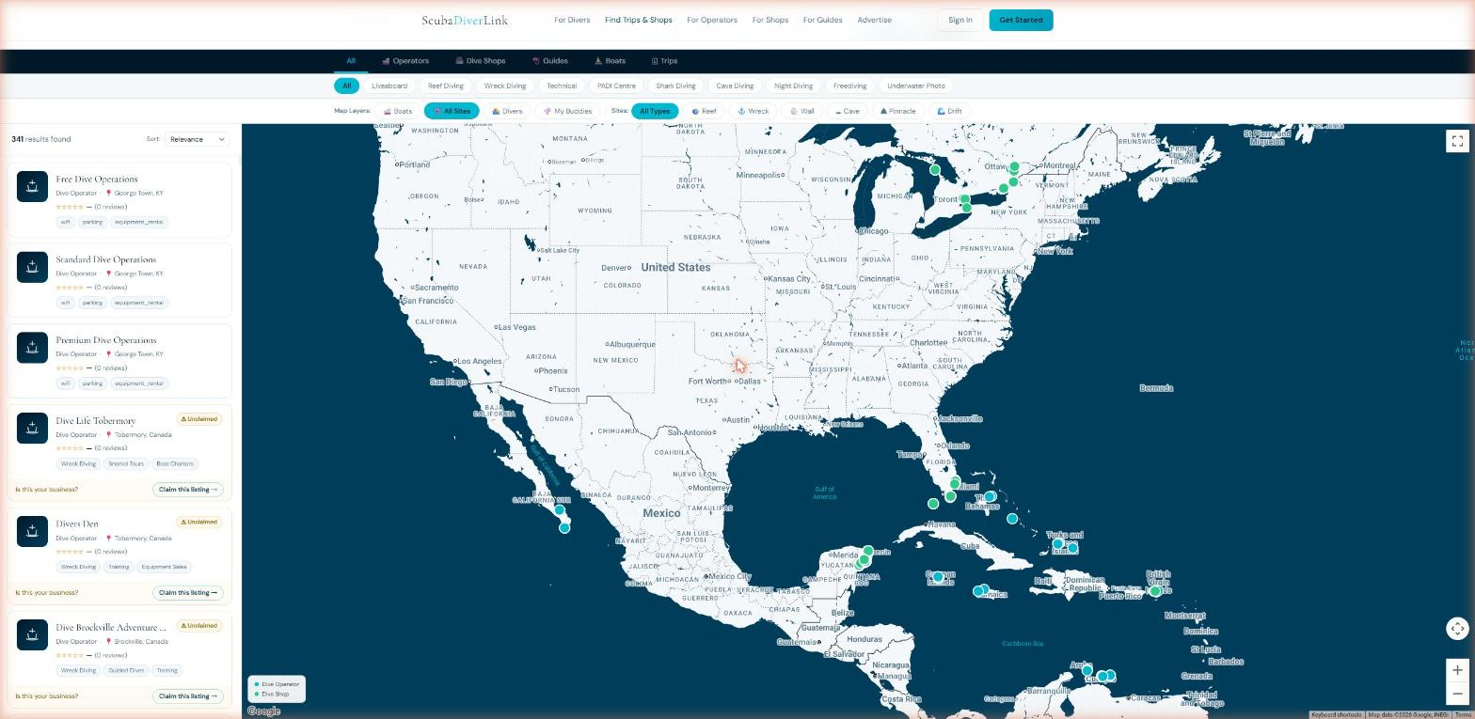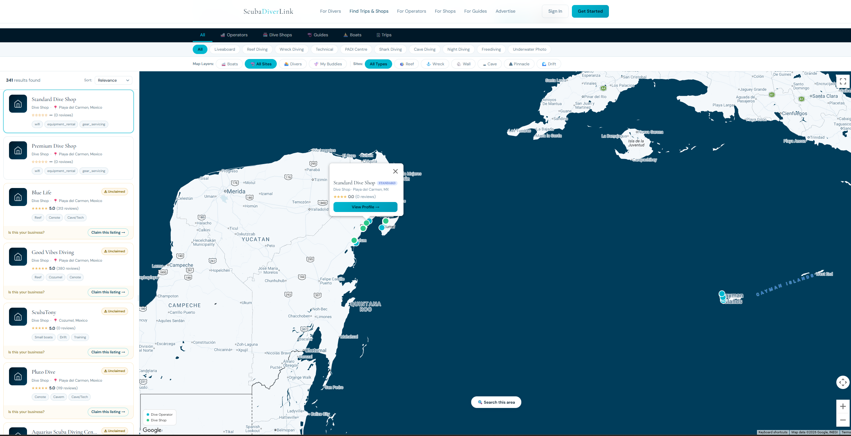

6.2 Viewing an Operator or Shop Profile
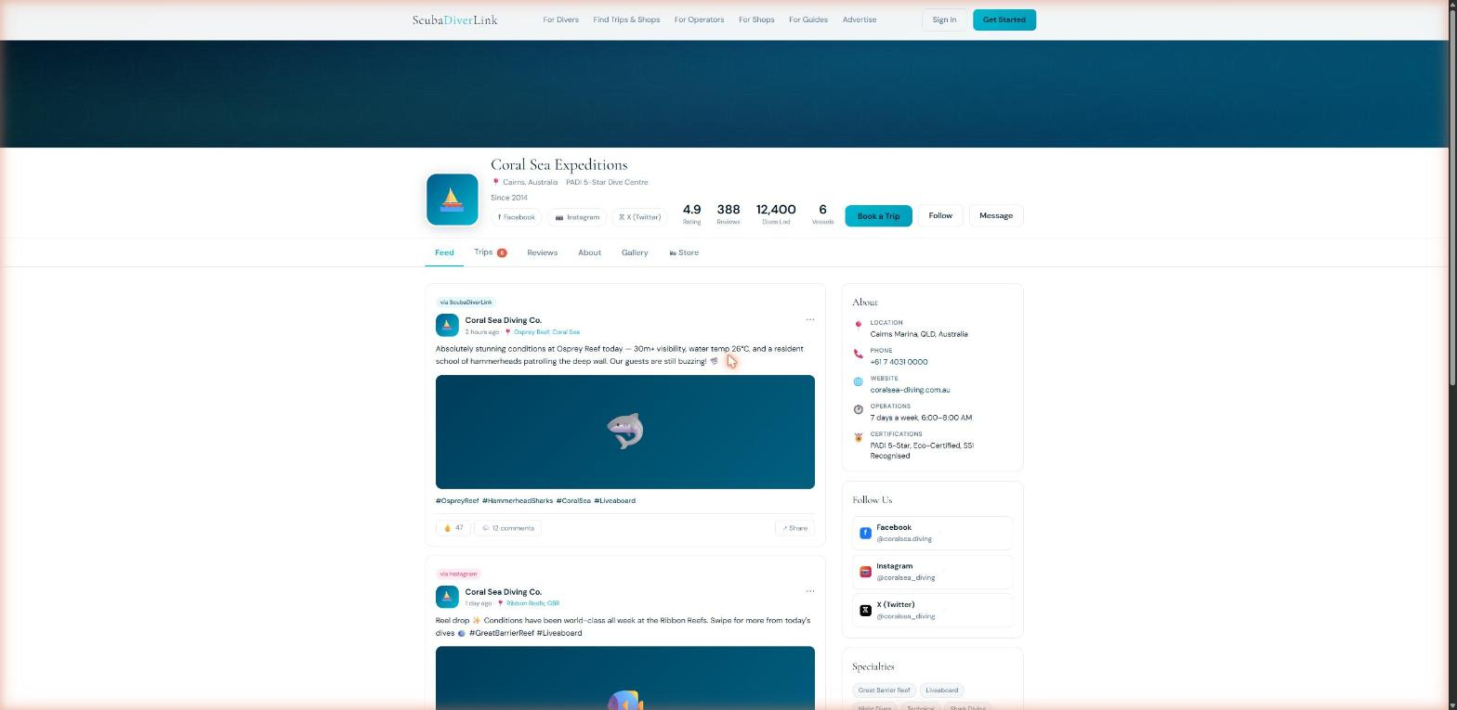
Click an operator or shop name anywhere on the platform to view their full profile: about section, certifications accepted, amenities, equipment, upcoming trips, reviews, and contact options. Click the heart icon in the header to save them to your Saved list.
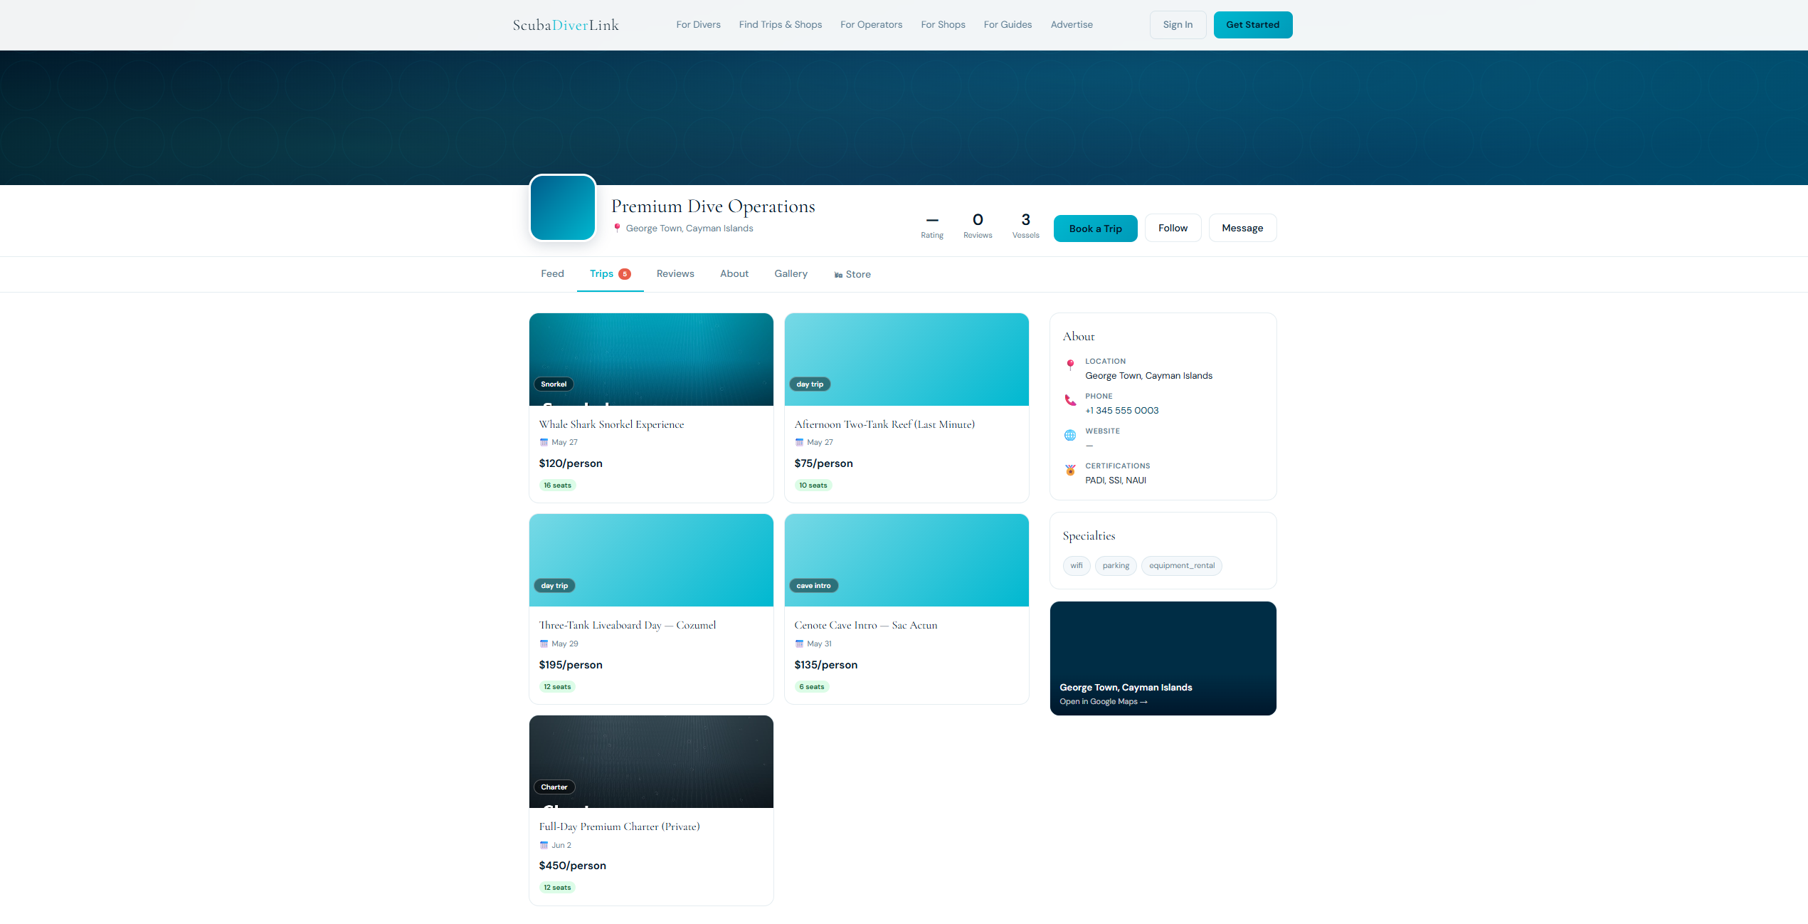

6.3 Booking a Trip
From an operator profile or search result, click a trip card to open the trip detail page. Then:
- Select the number of seats and review the price breakdown.
- Click Book Now. You will be redirected to the secure Stripe payment page.
- Pay the deposit (or full amount, depending on the operator's policy).
- You will receive a booking confirmation email. Your booking appears in My Trips.
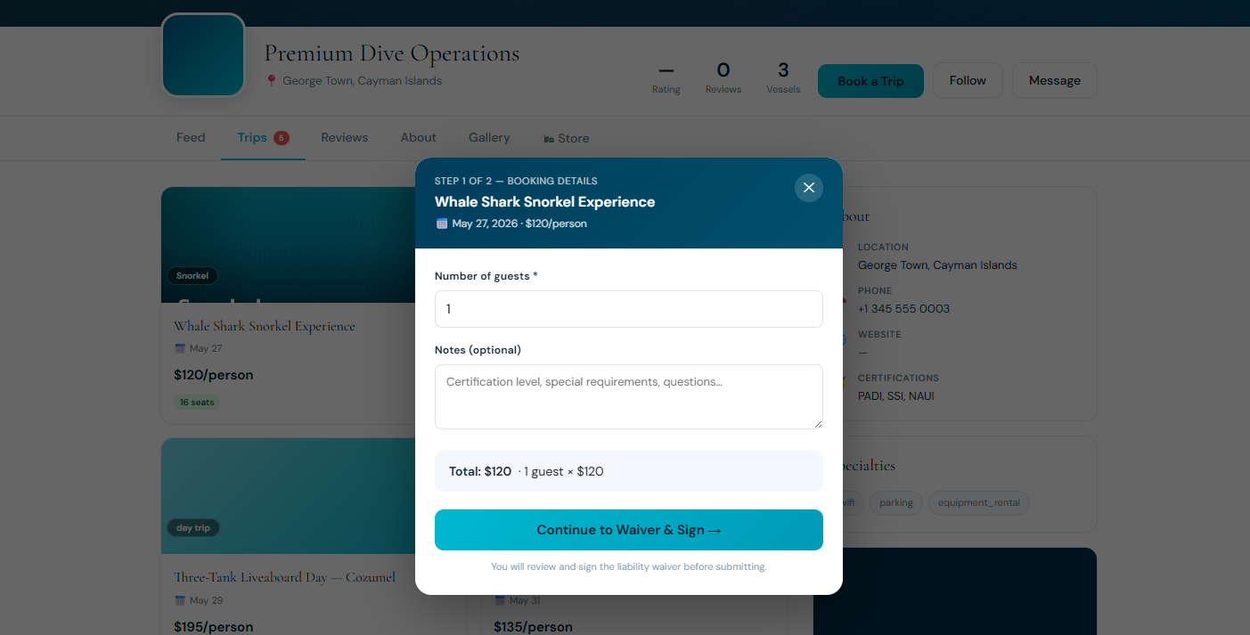

6.5 Signing the Waiver
Most operators require a liability waiver before your booking is fully confirmed. When a waiver is available, a Sign Waiver button appears on your trip detail page. Read through the waiver, tick the acknowledgement checkbox, and click Sign to record your signature. You can download the signed waiver for your records.
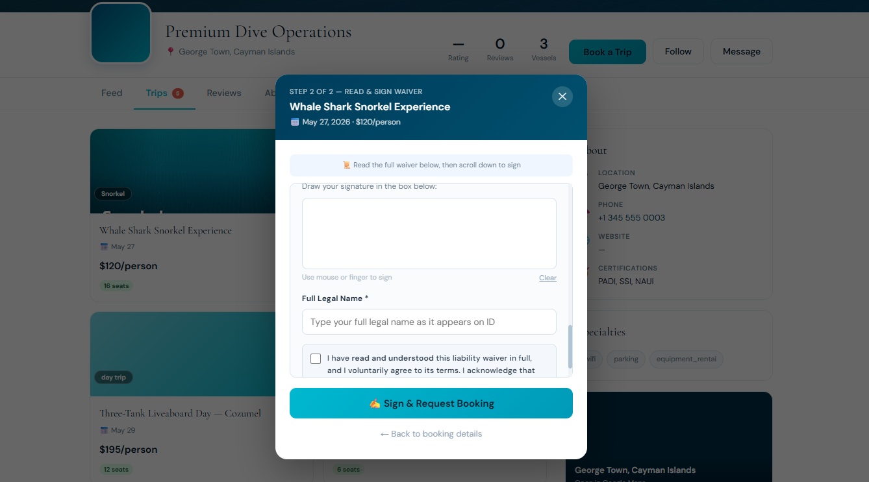

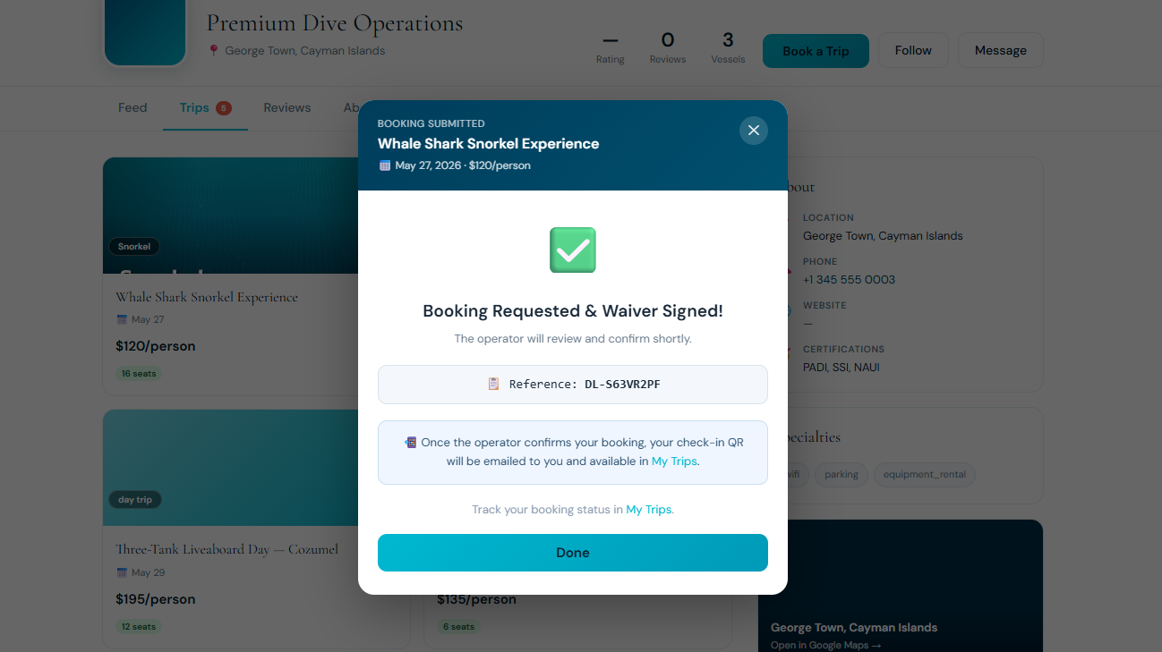

Each operator sets their own deposit and balance-due policy. Read the booking terms on the trip page before confirming.

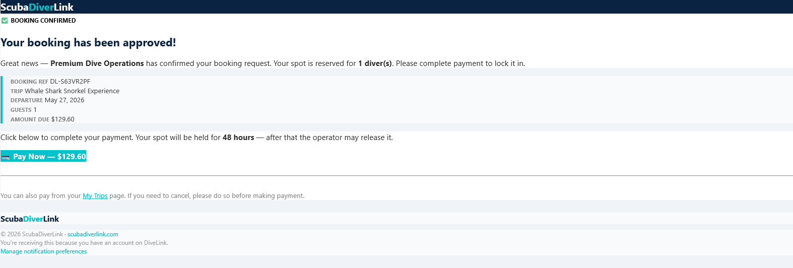

6.4 The Seat Map
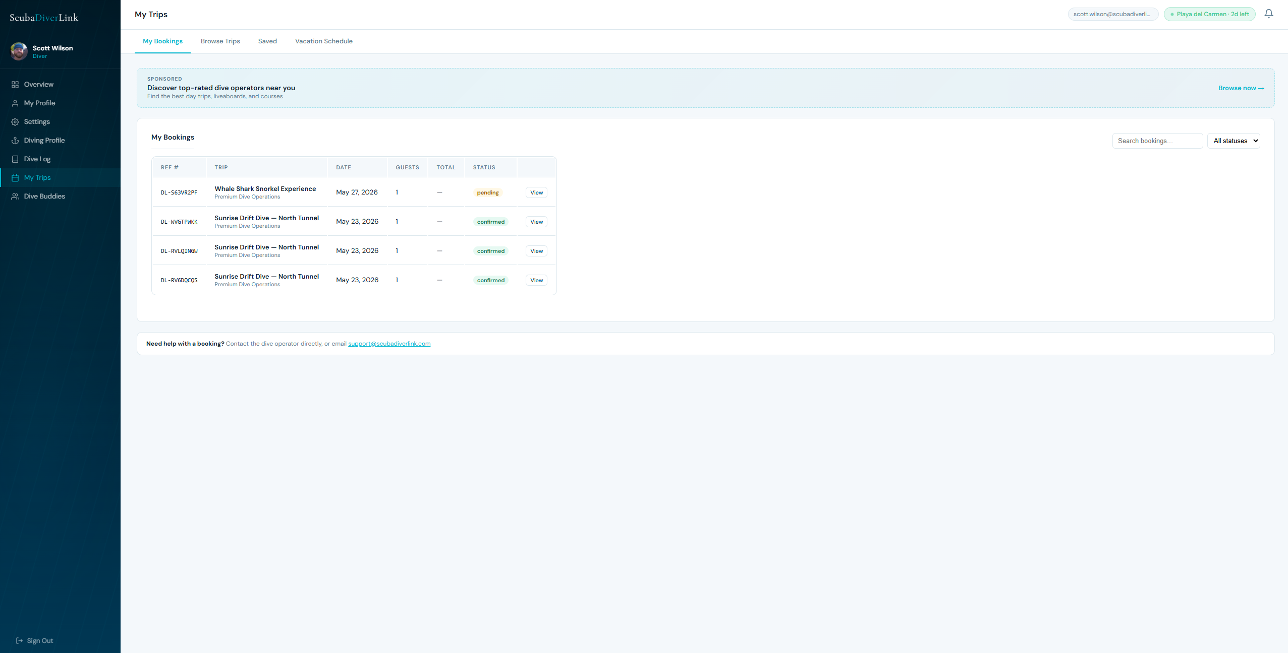
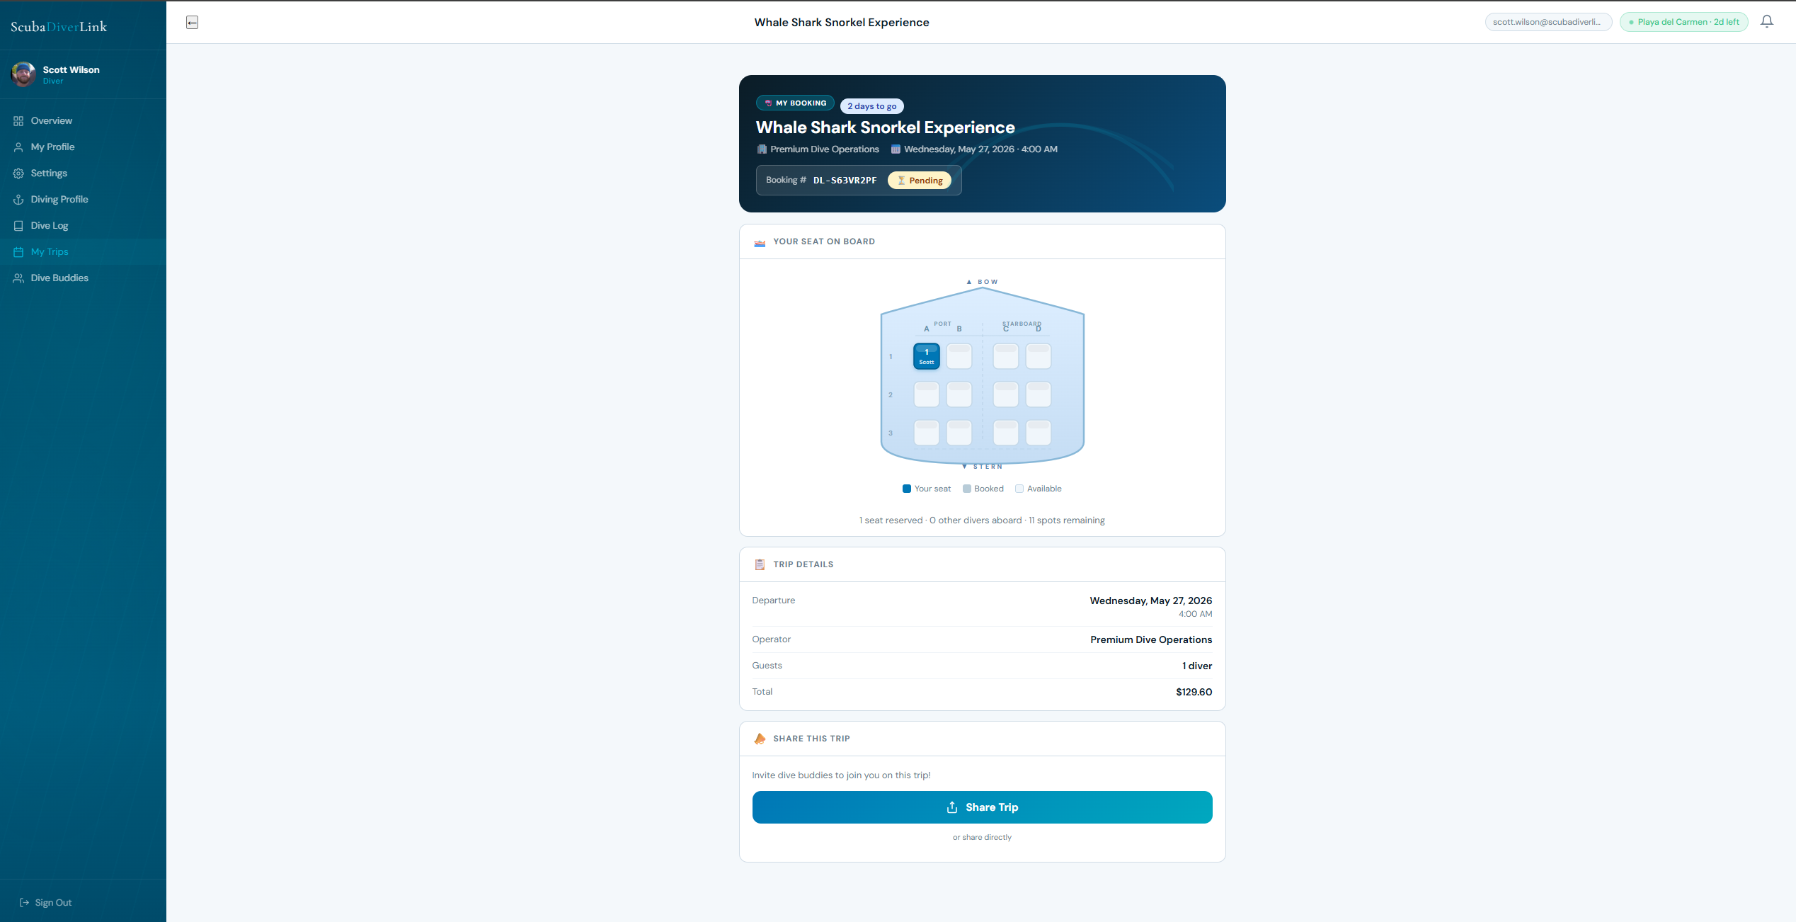

The interactive seat map shows the boat layout with available, taken, and your assigned seats highlighted. The legend at the bottom explains each colour. Seat assignment is managed by the operator.

6.6 Paying the Balance
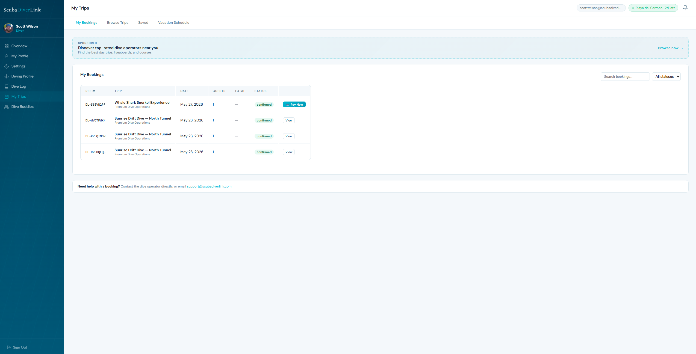
If you paid a deposit at booking, the remaining balance becomes due before the date set by the operator. A Pay Balance button appears on your trip page when the balance is due. Click it to complete payment via Stripe. You will receive a receipt by email.

7. My Trips
Track all your bookings — past, present, and upcoming — manage your vacation schedule, and share your adventures with friends.

7.1 My Bookings
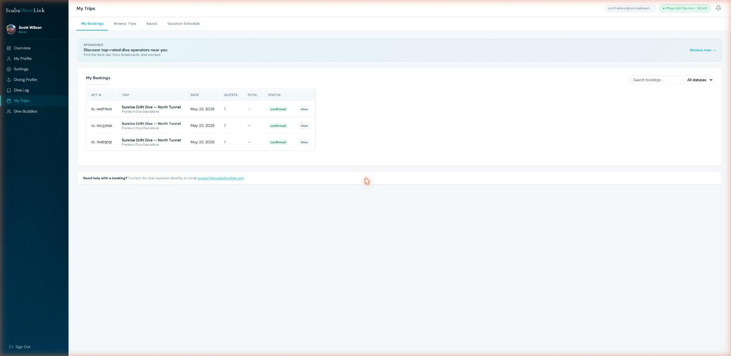
The Bookings tab lists all your trips with their current status:

Confirmed | Your booking and payment are complete. You are on the manifest.
Pending | Awaiting operator confirmation or payment completion.
Completed | The trip has departed. You can now leave a review.
Cancelled | The booking was cancelled (by you or the operator).

Each confirmed booking shows a countdown to departure and a Check-In button when the trip date arrives.

7.2 QR Boarding Pass
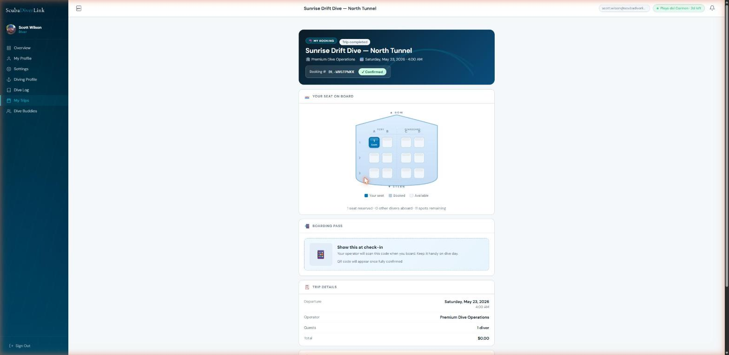

Once your waiver is signed and payment is complete, a QR code boarding pass is generated automatically. Present this to the operator's crew at the dock for a fast check-in. The operator scans it with the ScubaDiverLink scan terminal to mark you as boarded.

7.3 Sharing Your Trip
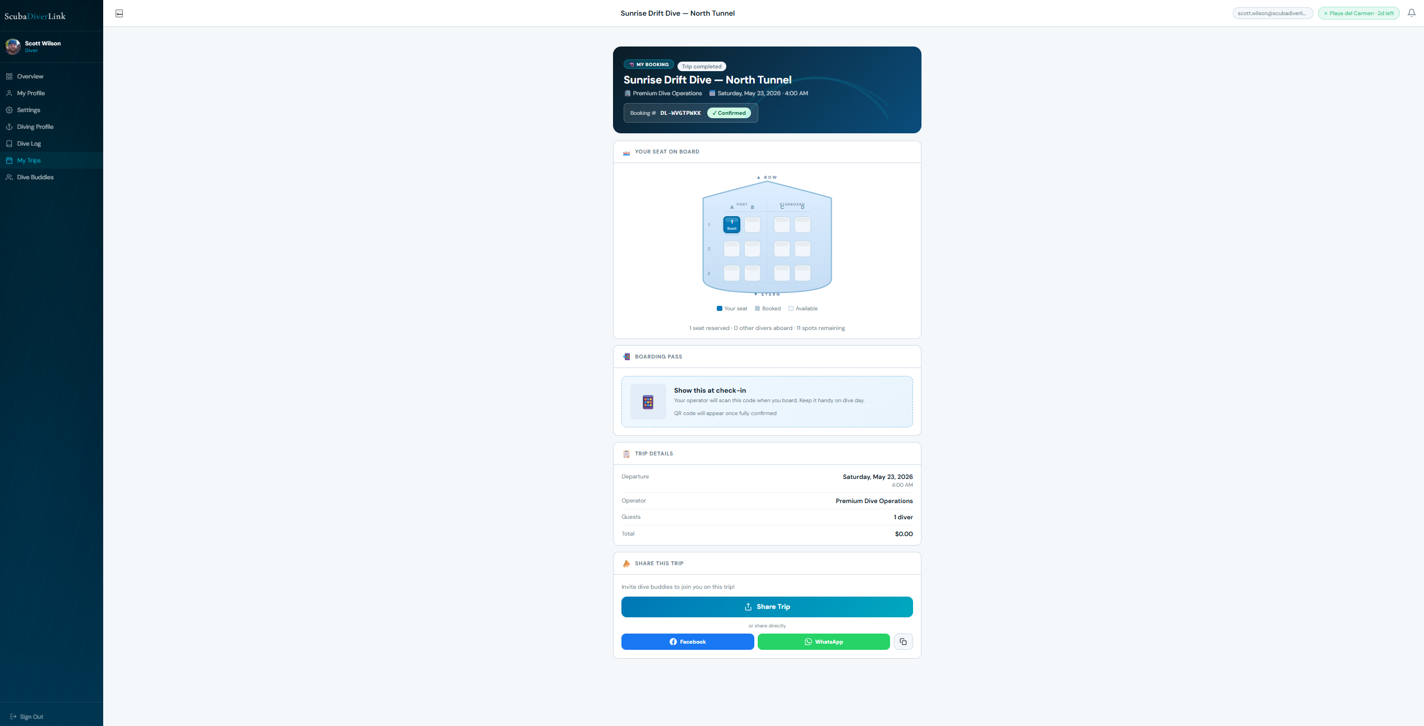
On the trip detail page, use the Share buttons to post your trip to Facebook or send it via WhatsApp. Sharing generates a link to the operator's public profile with your trip details, making it easy to invite dive buddies.

7.4 Browse Trips
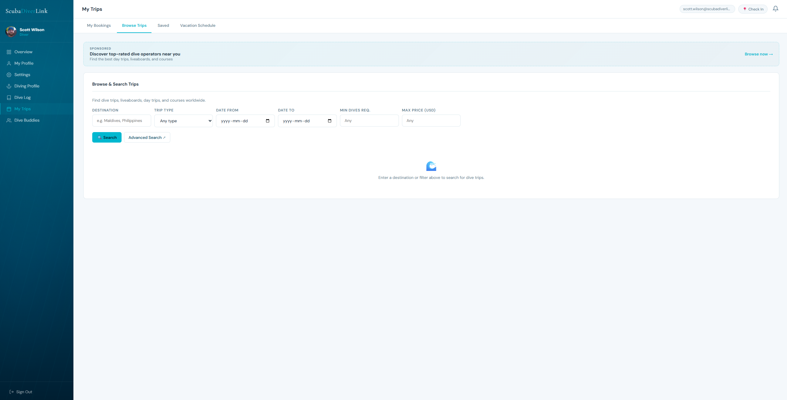
The Browse tab gives you a quick trip search directly inside the app — no need to go back to the public search page. Filter by trip type, dates, and destination.

7.5 Saved Trips
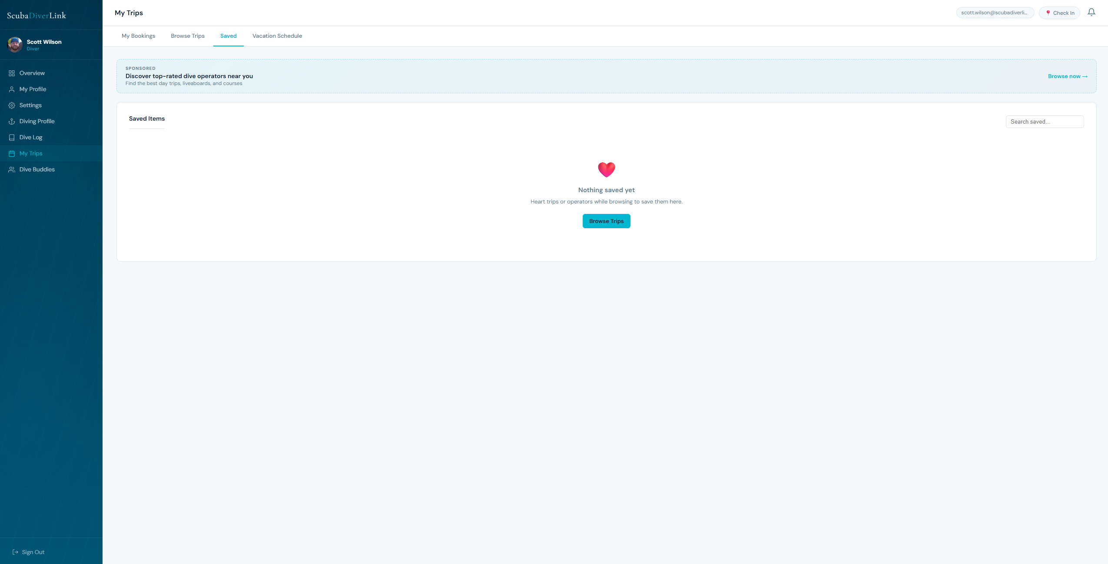
Trips you save from the search or operator profile pages appear here. Review them later or click Book to proceed with a booking.

7.6 Vacation Schedule and Location Check-in
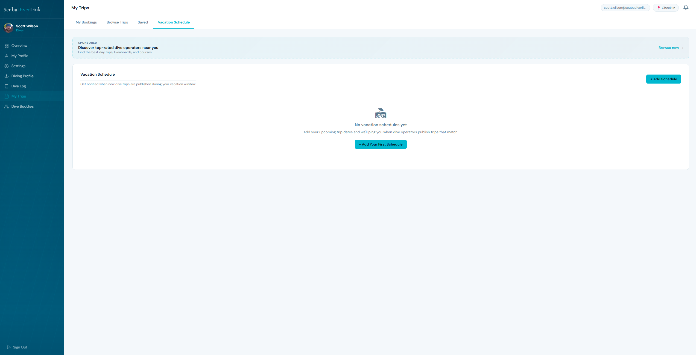
Tell ScubaDiverLink where and when you will be travelling, and it will automatically alert you when a new trip is published that matches your criteria.
To add a vacation:
- Click + Add Vacation.
- Enter your destination (e.g. Maldives, Philippines).
- Set your arrival and departure dates.
- Select the dive types you are interested in.
- Set a search radius (in km) around your destination.
- Click Save. You will receive a notification whenever a matching trip is published.
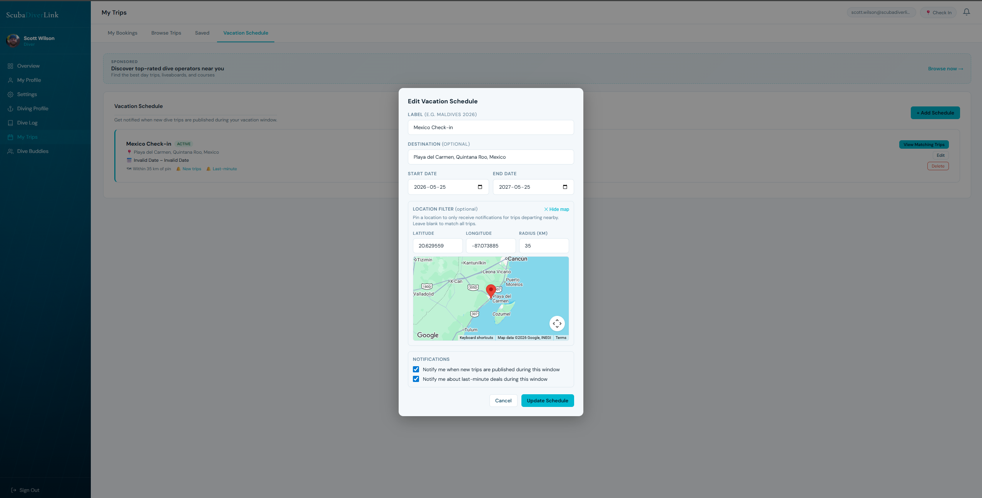

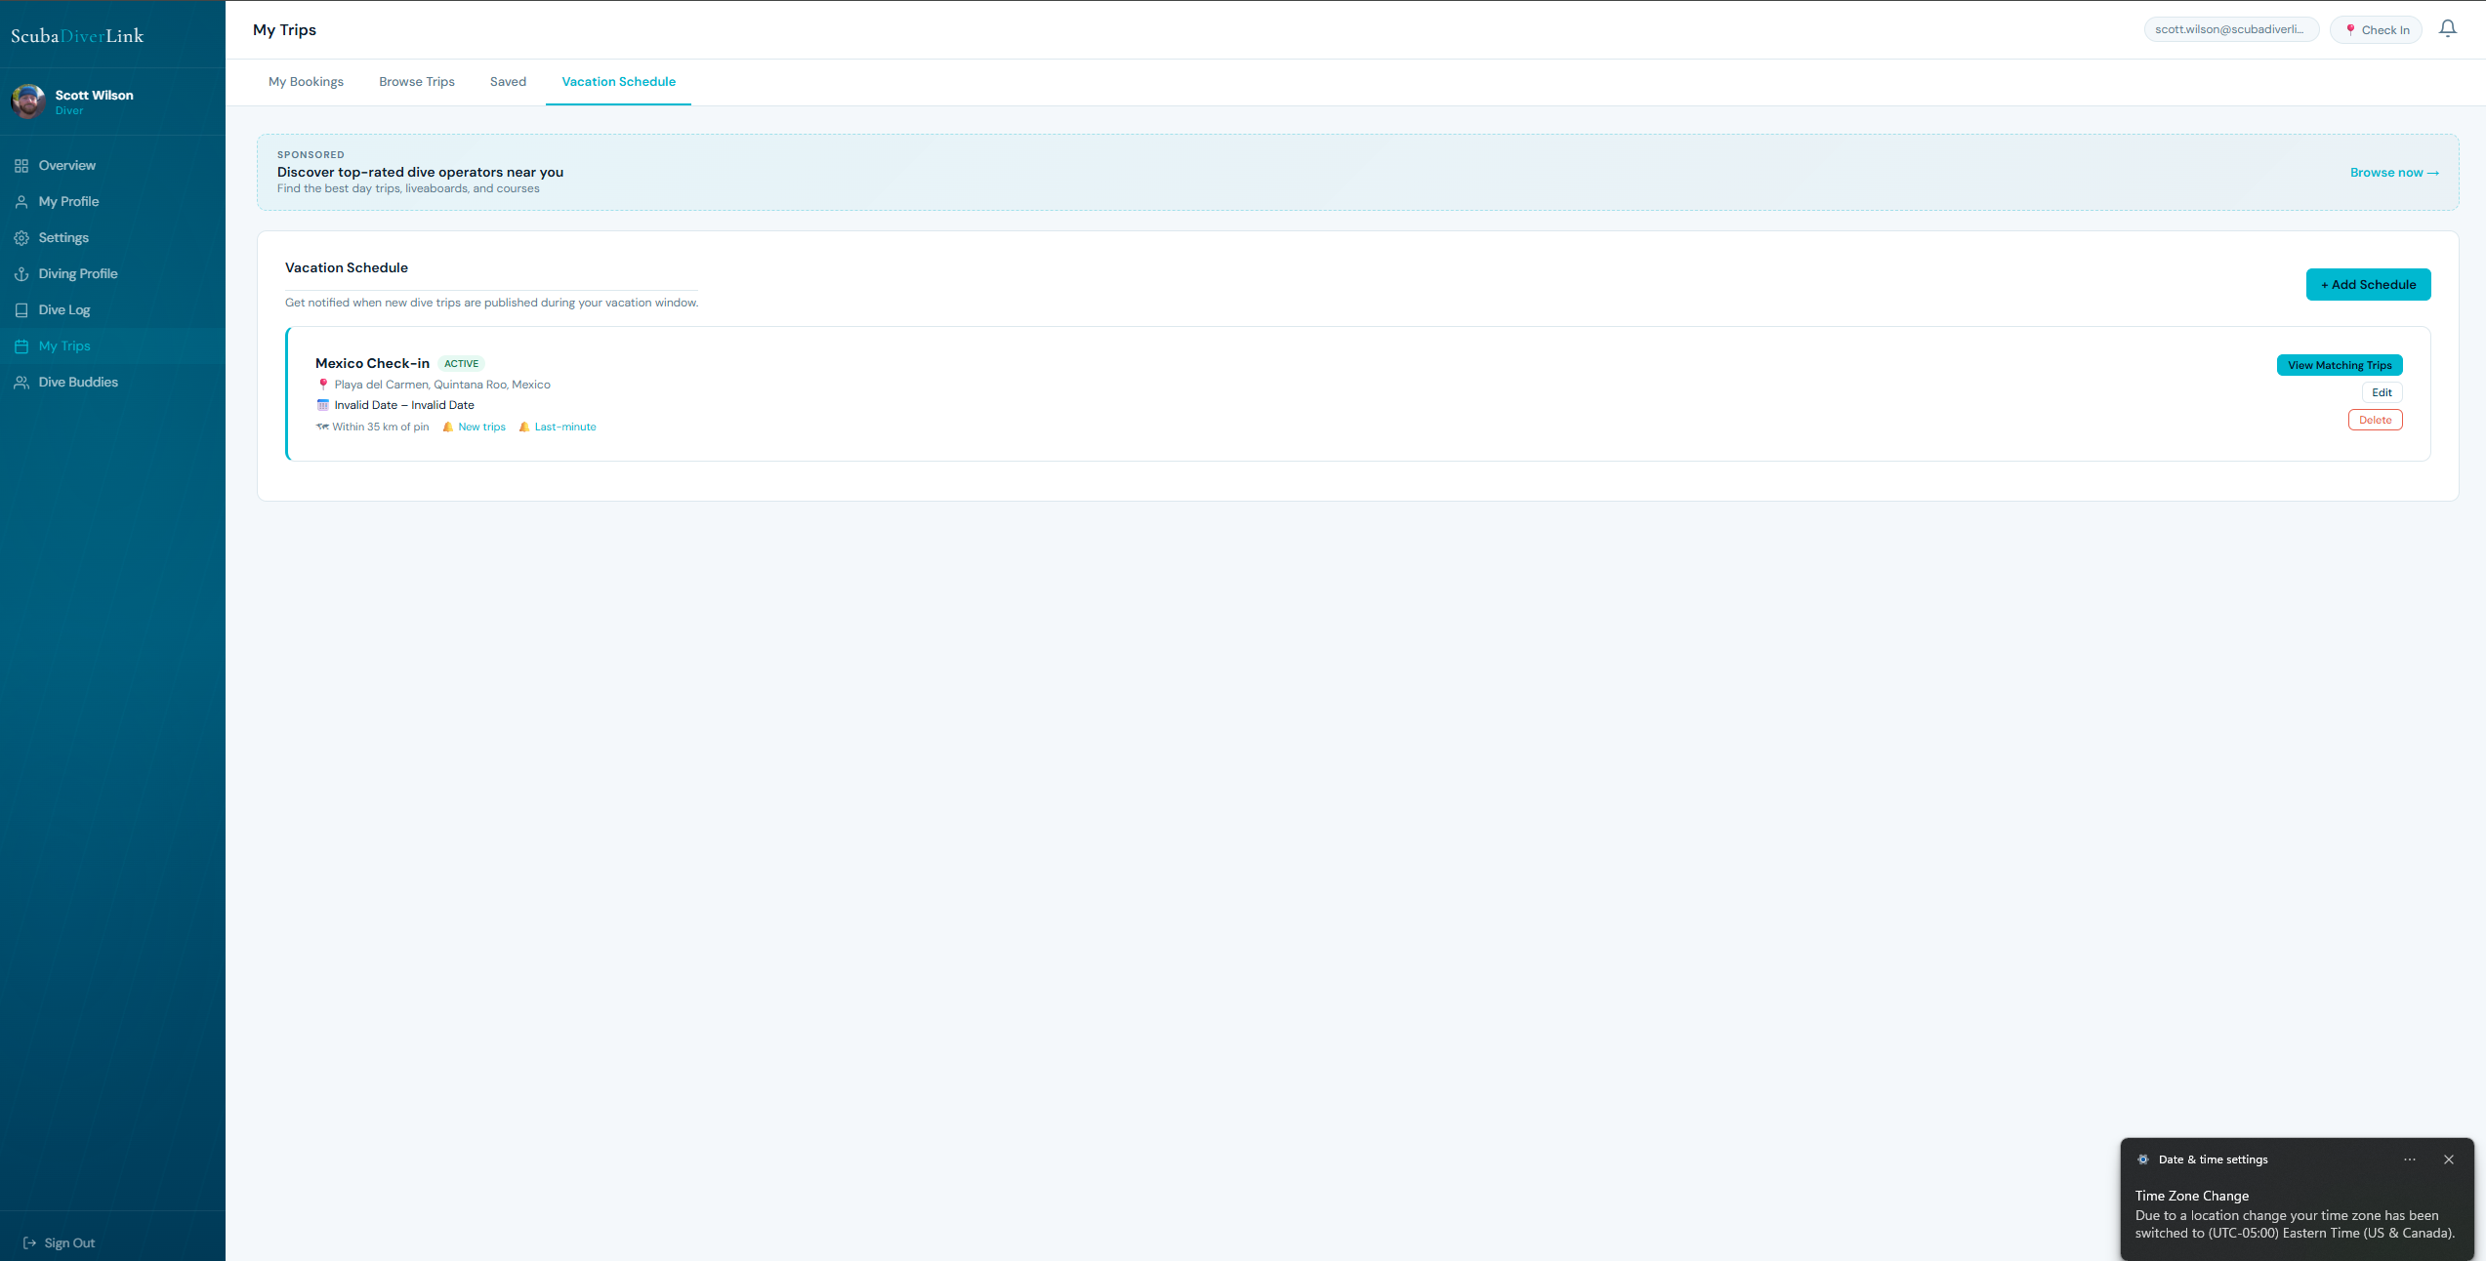
View Matching trips
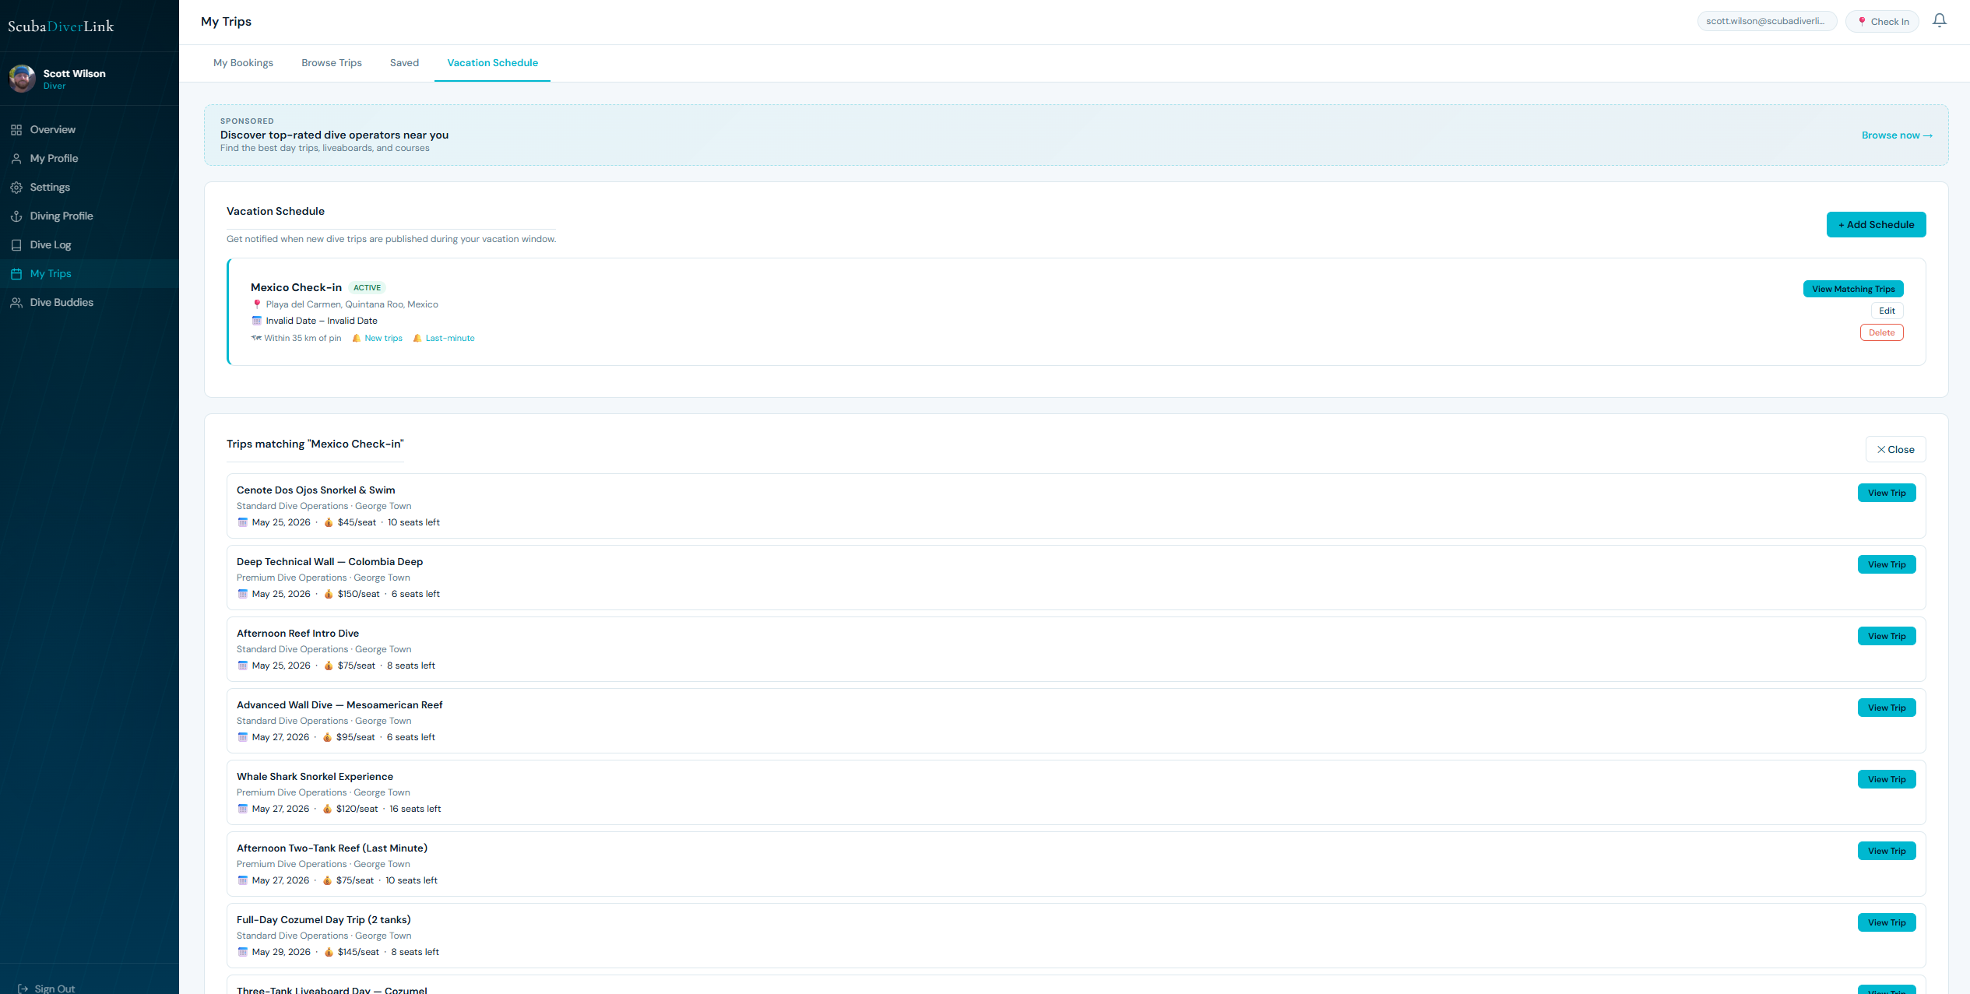
Short Term Check-in at a location:
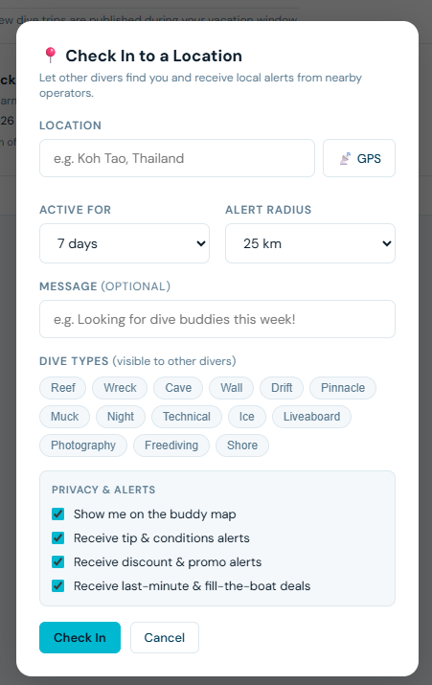

8. Settings
Control your security, notifications, subscription, and account preferences from one place.

8.1 Emergency Contact
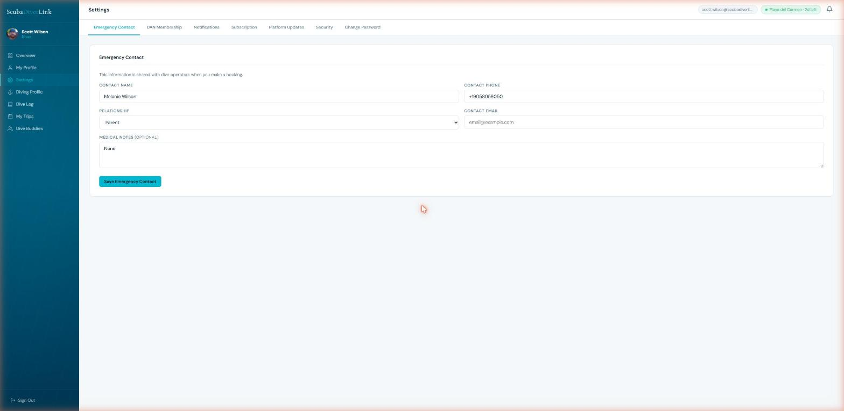
Enter the name, relationship, and phone number of someone to contact in an emergency. This information is shared with operators when you make a booking.

8.2 DAN Membership
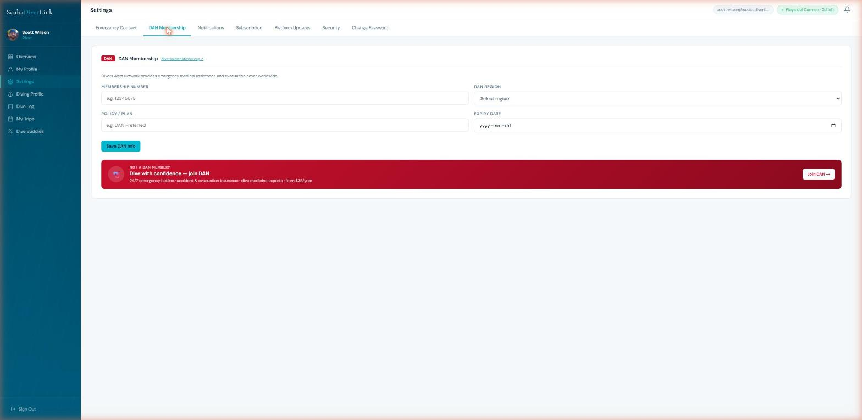
Enter your Divers Alert Network (DAN) membership number and upload a photo of your DAN card. Operators can see your DAN status on your booking record.

8.3 Notifications
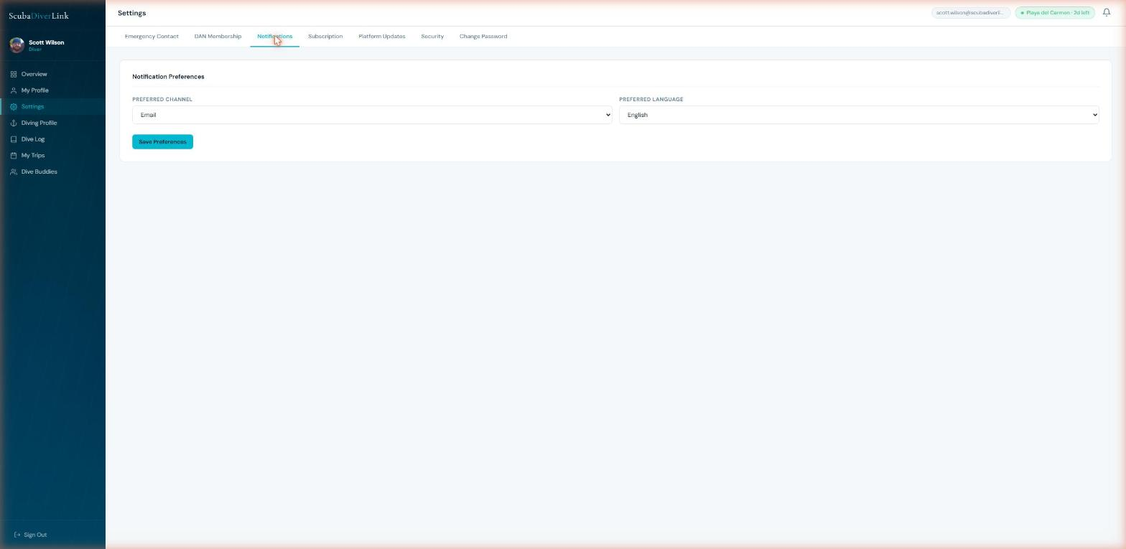
Choose which events trigger a notification and how you receive them (email, SMS, or in-app). Available notification types include booking confirmations, payment reminders, trip departure reminders, new messages from operators, and vacation schedule matches.

8.4 Subscription
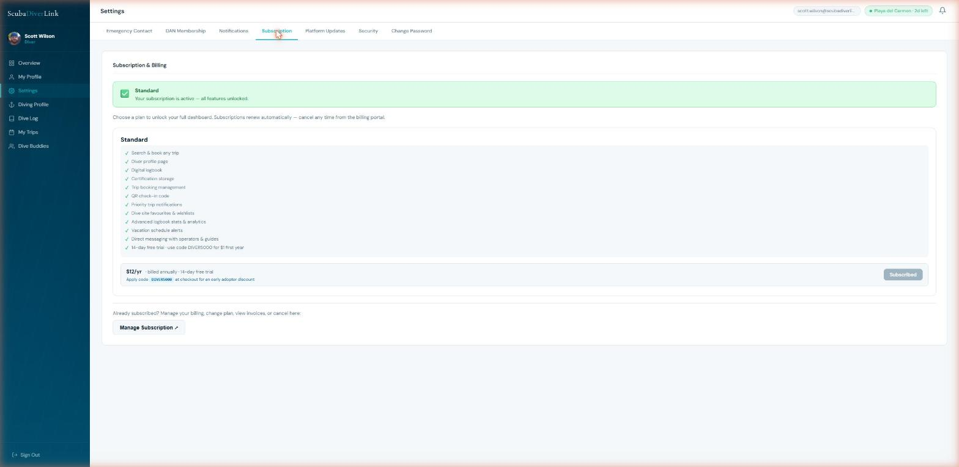
ScubaDiverLink Standard is $12 per year for divers (use promo code DIVER5000 for $1 in your first year — limited to the first 5,000 sign-ups). Standard unlocks:
- Unlimited dive log entries.
- Advanced statistics and export.
- Priority search placement when operators search for available divers.
- Exclusive member deals from partner operators.

Your 14-day free trial includes all Standard features. No credit card is required during the trial.

8.5 Security (MFA & Password)
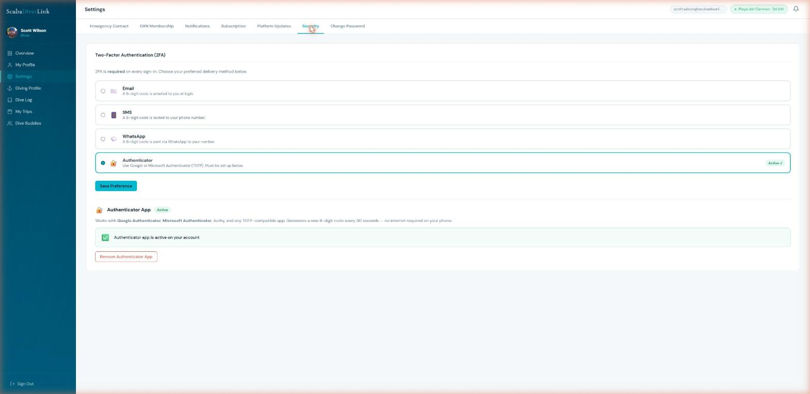
Change your MFA method at any time. To set up an Authenticator app:
- Select Authenticator App and click Set Up.
- Scan the QR code with Google Authenticator, Authy, or a compatible TOTP app.
- Enter the 6-digit code shown in your app to confirm setup.

To change your password, go to the Change Password tab. Enter your current password and your new password twice. Click Update Password.
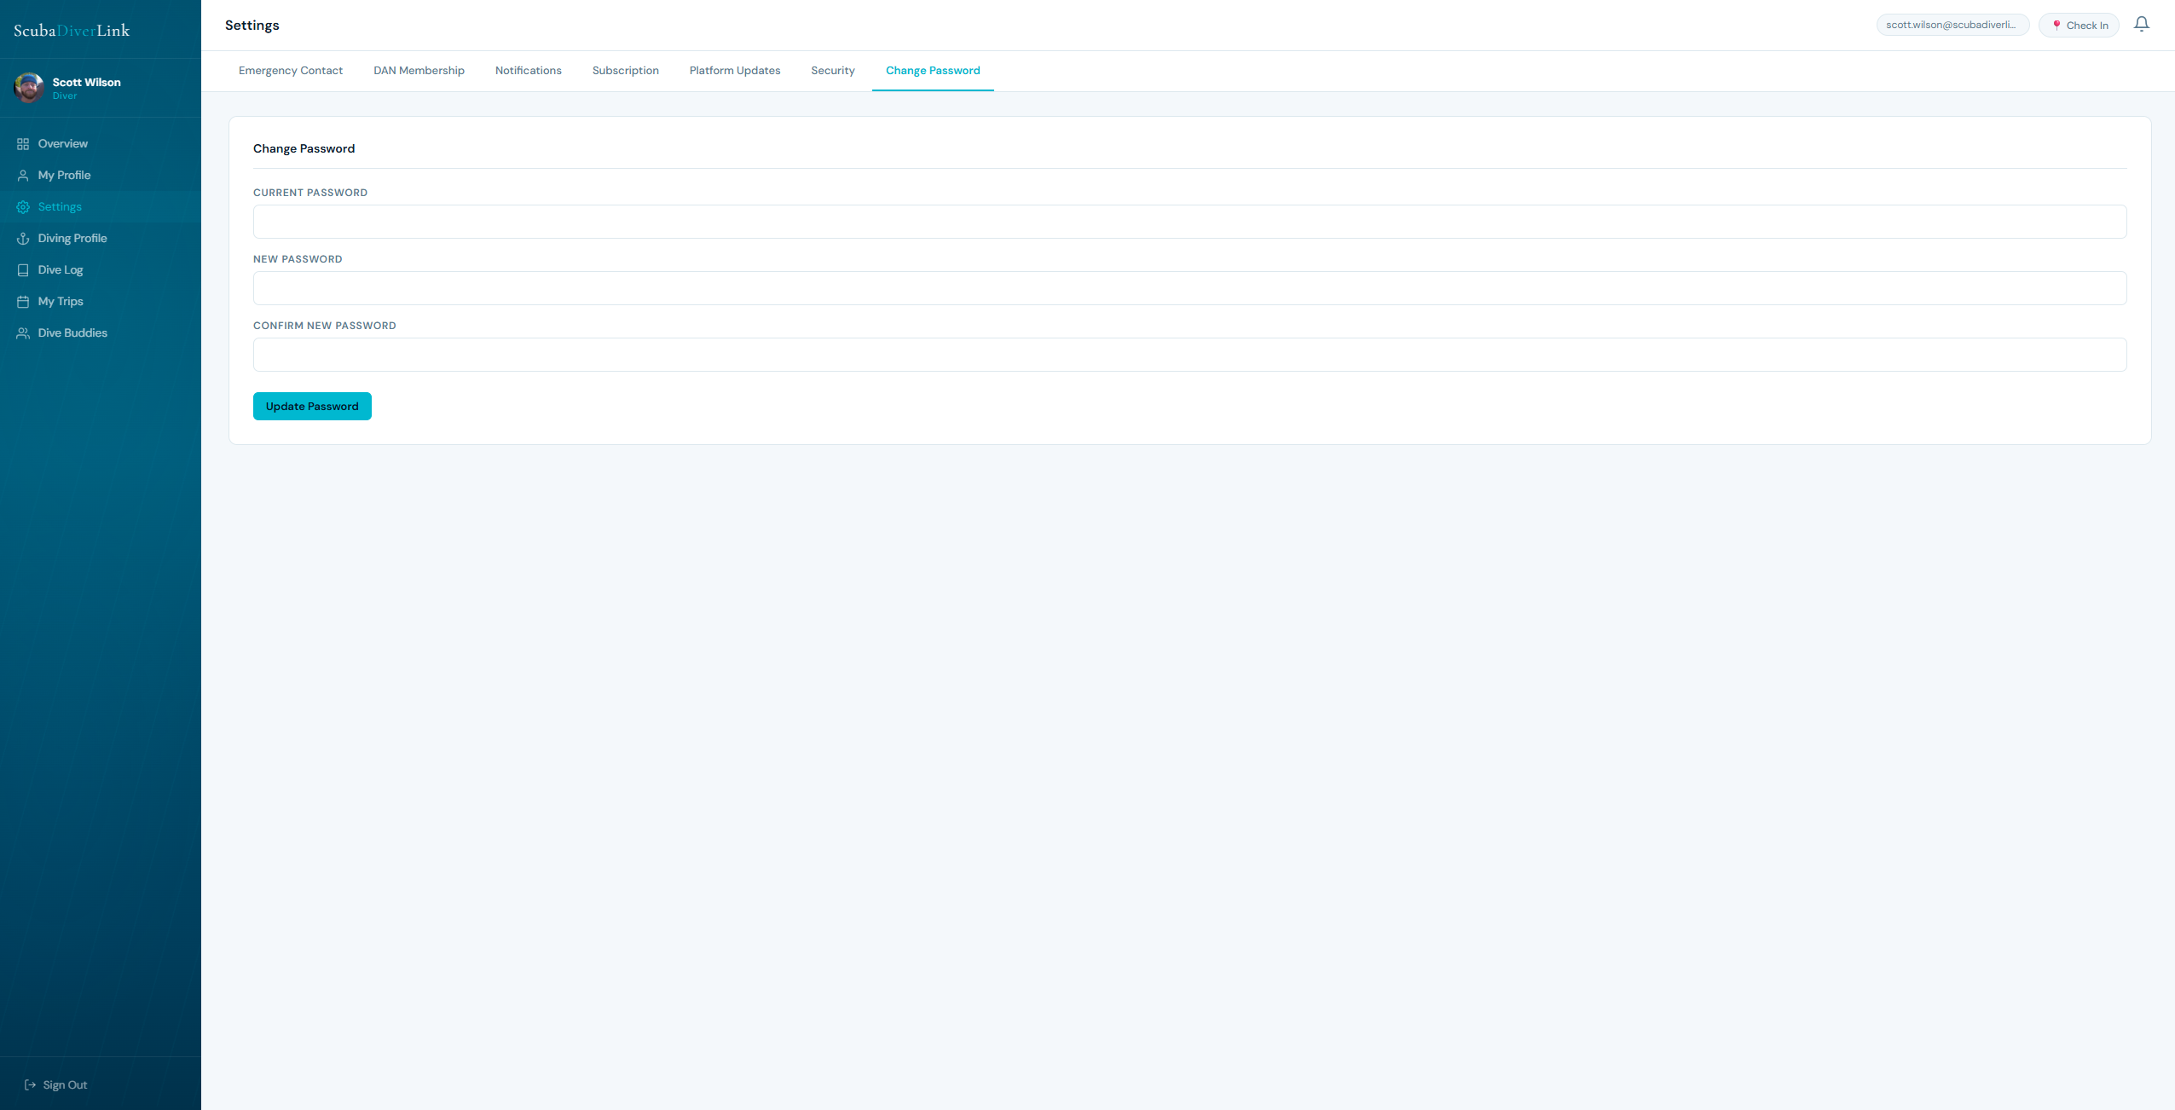

8.6 Platform Updates
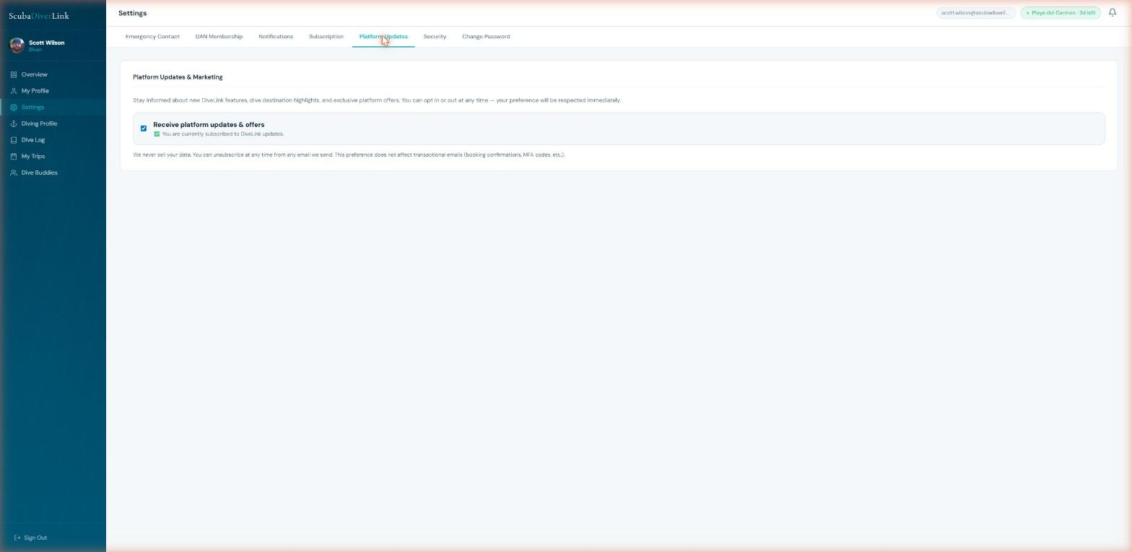

Opt in or out of ScubaDiverLink platform announcements, new feature highlights, and diving community newsletters. This does not affect booking or security notifications.

9. Dive Buddies
Connect with other divers, find trip companions, and build your dive community on ScubaDiverLink.
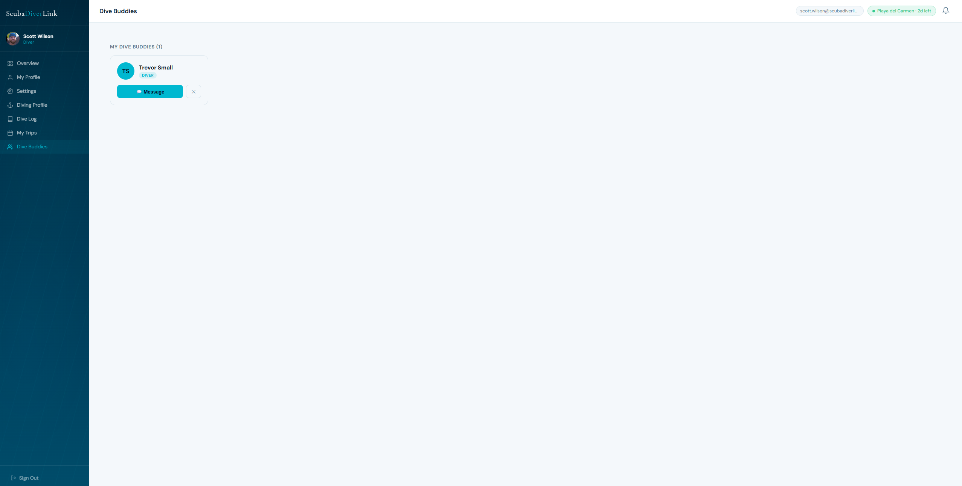

9.1 Finding Divers
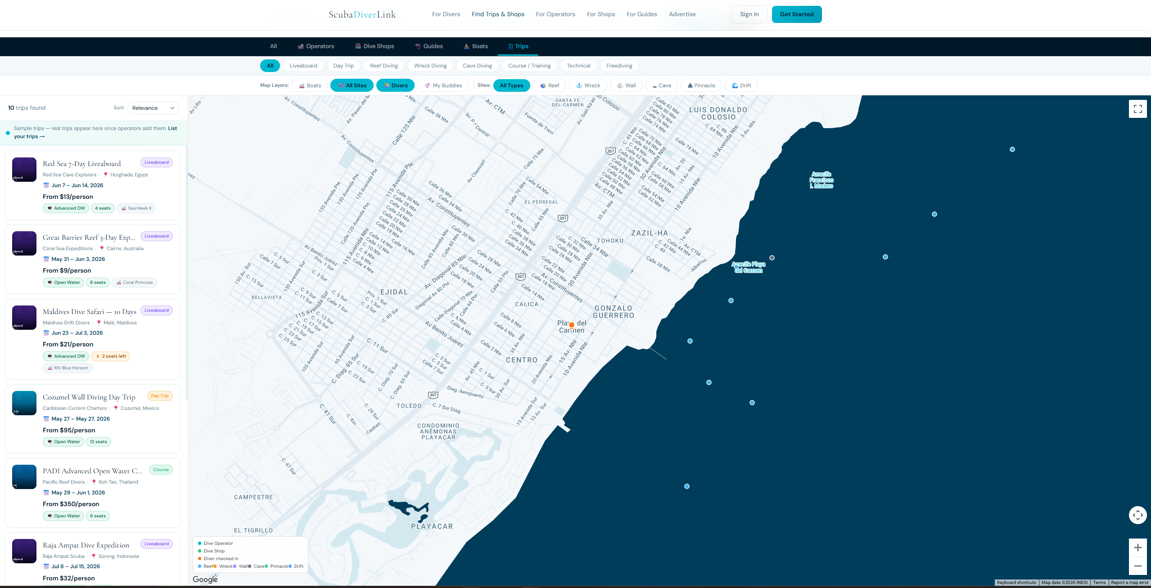
Browse registered divers by name, location, or certification level. Click a diver card to view their public profile with dive log stats, equipment, and shared dive types.
Searching for your dive buddy
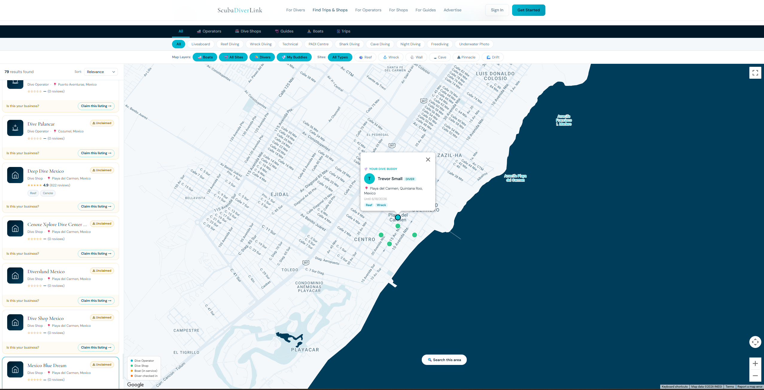

Searching for other Divers
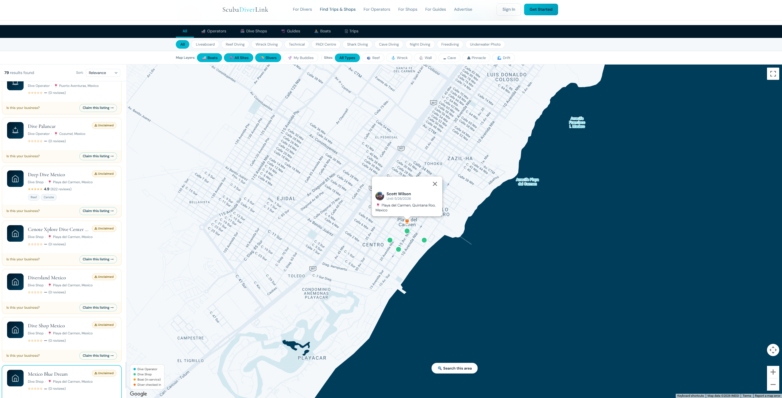

9.2 Sending a Buddy Request
Click Add Buddy on any diver profile. They will receive a notification. Once they accept, you appear in each other's Buddy lists and can send in-app messages. Your buddy list is visible to operators when reviewing your booking.

9.3 Messaging
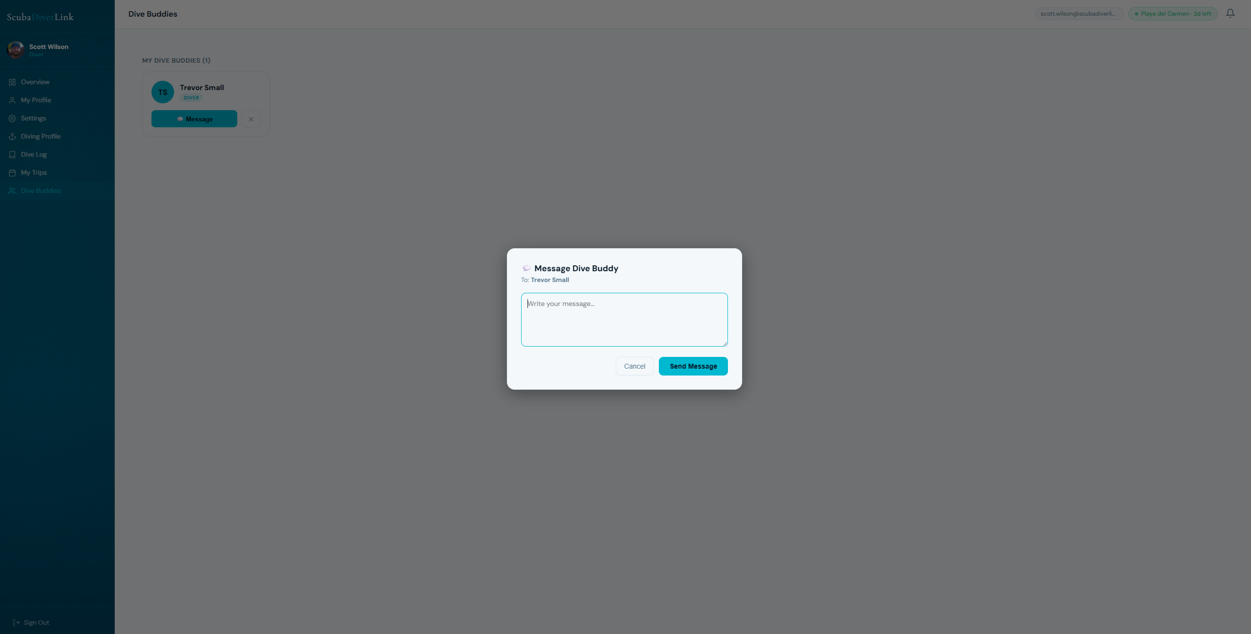
Accepted dive buddies can exchange messages directly in ScubaDiverLink. Open a buddy's profile and click Message. You will receive an email notification for new messages (configurable in Settings → Notifications).

10. Tips & Troubleshooting

10.1 Common Issues
Didn't receive verification email | Check your spam folder. Wait 5 minutes. Go to the login page and click Resend Verification Email.
MFA code not working | Codes expire after 10 minutes. Request a new one. For TOTP apps, ensure your phone's clock is synchronized.
Can't pay balance | The payment deadline set by the operator may have passed. Contact the operator directly.
QR code not showing | Make sure your waiver is signed and your deposit payment has been confirmed.
Dive import shows wrong depths | UDDF files use SI units (metres + Kelvin). Garmin CSV uses feet — ScubaDiverLink converts automatically. Check your source app's export settings.
Can't log in after password reset | Clear your browser cache and try again. Make sure you are using the link from the most recent reset email.

10.2 Getting Help
For further support, visit the ScubaDiverLink website or contact the operator you booked with directly. Operators can also reach their team through the in-app messaging system.

Platform: www.scubadiverlink.com
Login: www.scubadiverlink.com/login.html
Platform Support Ticket: support@scubadiverlink.com

Appendix — Quick Reference Links
All demo page URLs for quick screenshot capture. Open each link, take a screenshot, and drop it into the matching placeholder above.

Sign Up / Login | https://www.scubadiverlink.com/login.html
Overview Dashboard | https://www.scubadiverlink.com/app/overview.html
My Profile — Personal Info | https://www.scubadiverlink.com/app/my-profile.html?tab=personal
My Profile — Photo | https://www.scubadiverlink.com/app/my-profile.html?tab=photo
My Profile — Saved | https://www.scubadiverlink.com/app/my-profile.html?tab=saved
Diving Profile — Experience | https://www.scubadiverlink.com/app/diving-profile.html?tab=experience
Diving Profile — Certs | https://www.scubadiverlink.com/app/diving-profile.html?tab=certs
Diving Profile — Dive Types | https://www.scubadiverlink.com/app/diving-profile.html?tab=dive-types
Diving Profile — Equipment | https://www.scubadiverlink.com/app/diving-profile.html?tab=equipment
Dive Log — My Logs | https://www.scubadiverlink.com/app/dive-log.html?tab=logs
Dive Log — Import | https://www.scubadiverlink.com/app/dive-log.html?tab=import
Dive Log — Stats | https://www.scubadiverlink.com/app/dive-log.html?tab=stats
Search Trips | https://www.scubadiverlink.com/search.html
Operator/Shop Profile | https://www.scubadiverlink.com/profile.html
Trip View / Booking | https://www.scubadiverlink.com/app/trip-view.html
My Trips — Bookings | https://www.scubadiverlink.com/app/my-trips.html?tab=bookings
My Trips — Browse | https://www.scubadiverlink.com/app/my-trips.html?tab=browse
My Trips — Saved | https://www.scubadiverlink.com/app/my-trips.html?tab=saved
My Trips — Vacation Schedule | https://www.scubadiverlink.com/app/my-trips.html?tab=schedule
Settings — Emergency Contact | https://www.scubadiverlink.com/app/settings.html?tab=emergency
Settings — DAN | https://www.scubadiverlink.com/app/settings.html?tab=dan
Settings — Notifications | https://www.scubadiverlink.com/app/settings.html?tab=notifications
Settings — Subscription | https://www.scubadiverlink.com/app/settings.html?tab=subscription
Settings — Security / MFA | https://www.scubadiverlink.com/app/settings.html?tab=security
Settings — Platform Updates | https://www.scubadiverlink.com/app/settings.html?tab=marketing
Dive Buddies | https://www.scubadiverlink.com/app/buddies.html

Log in with the test diver account (password: DiveTest2024!) before capturing screenshots to ensure all data and UI states are visible.

